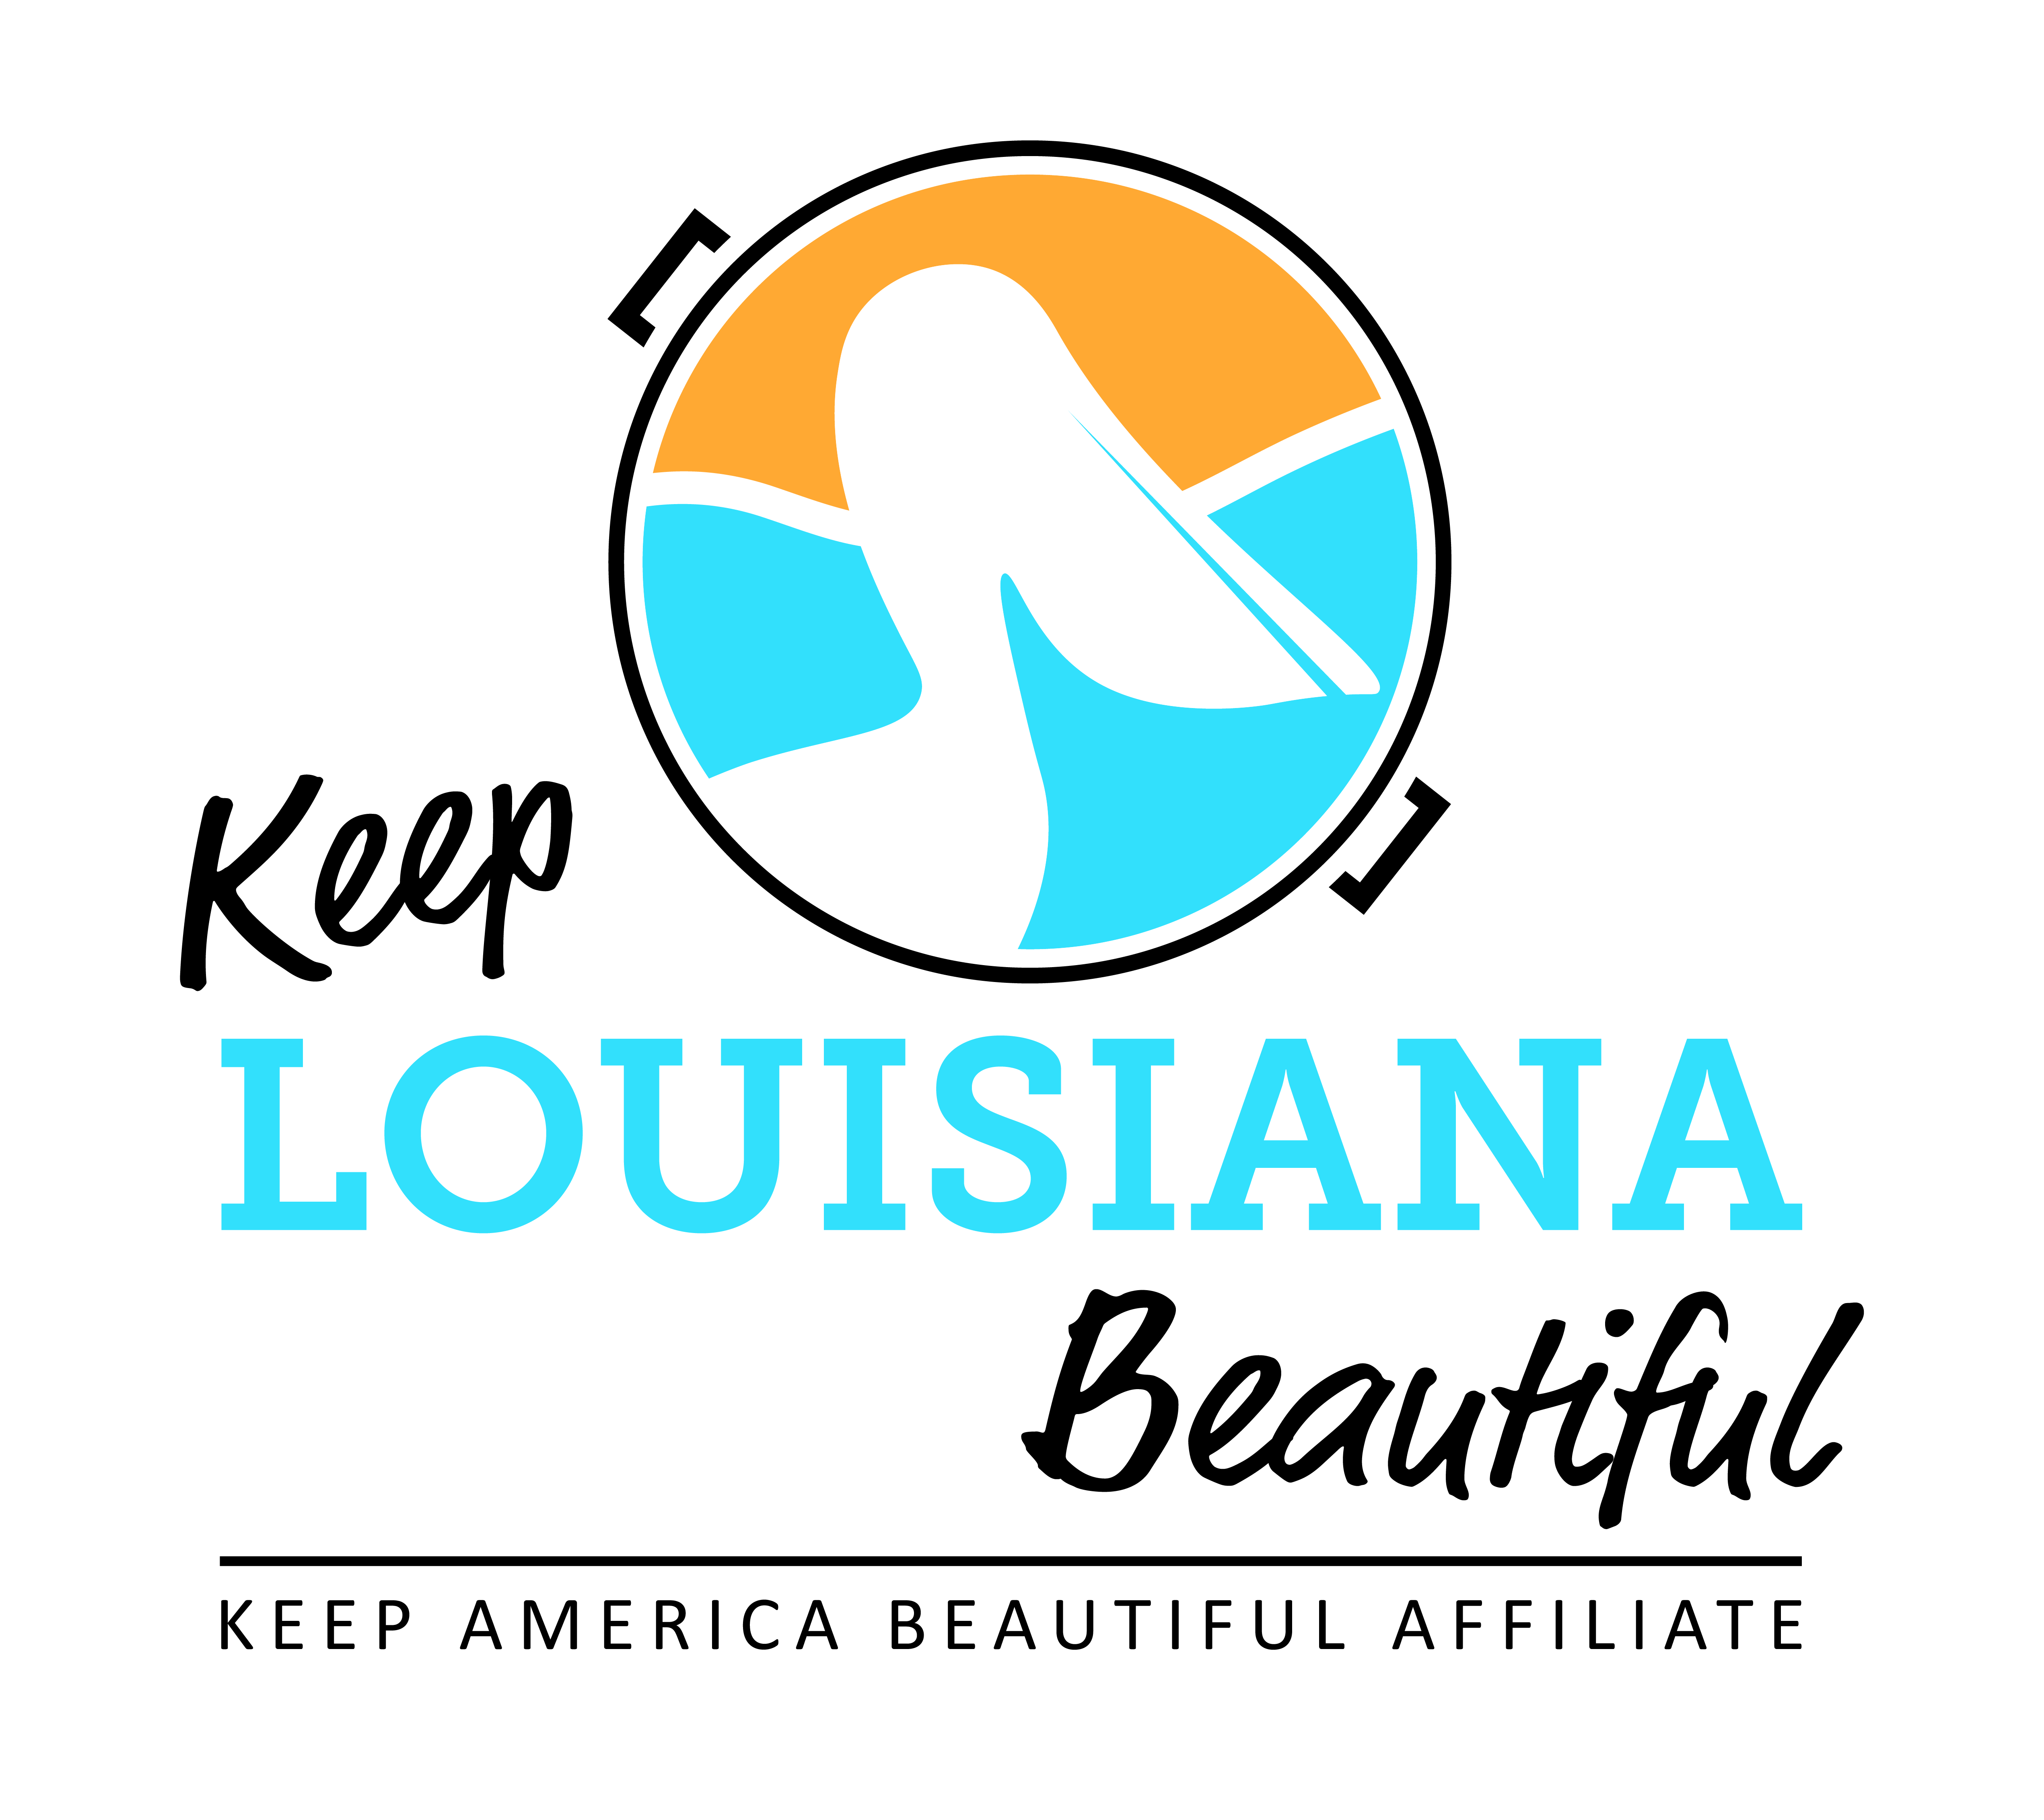

Affiliate Bi-Monthly Meeting Agenda
Thursday, March 16, 2023
8am or 3pm
Duration: 1 Hour
Link to meeting emailed one week prior.

- Affiliate Presentation: Keep Slidell Beautiful, Marissa Frischhertz
How to Begin a Successful Community Service Program

- 2023-24 Affiliate Grants OPEN
  - Affiliate Grants: Cleanup Supply, Trash Receptacle, and Program
  - Applications on the Affiliate Resource Center

- 2022-23 Grant Reporting Dates
  - May 1: Healthy Communities Final Report and Affiliate Program Reports due

- Legislative Materials – Susan

- Library Cleanup Supply Loaner Program - Susan
  - Participating Libraries

- Love the Boot Week
  - April 17-23, 2023
  - LTB Kickoff Reception: Mon., April 17, LA State Museum, 660 N. 4th St., Baton Rouge, 10am
  - Cleanup following Kickoff Reception
  - Cleanup supplies

- Affiliate Regional Meetings
  - May 16: Joseph S. Yenni Building, 1221 Elmwood Park Blvd., Second Floor, Jefferson
  - June 20: Greater Shreveport Chamber of Commerce, 400 Edwards St., Shreveport
  - June 21: SEED Center, McNeese University Campus, 4310 Ryan St., Lake Charles

- State Conference
  - Save the Date: October 10 and 11
  - Hilton Capitol Center, Baton Rouge
  - Topic and presenter ideas

II. Next affiliate conference call 5/18/23

