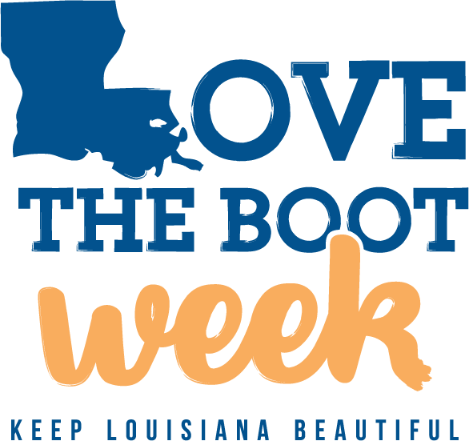
Add Your Logo

Media Contact:
[Name]
[Job Title]
[Email address]
[Phone number]
[Website]

FOR IMMEDIATE RELEASE:
[Release Date]

[YOUR ORGANIZATION] TO HOLD [CLEANUP/BEAUTIFICATION]
EVENT ON [DATE] FOR LOVE THE BOOT WEEK
Love the Boot Week, April 17-23, 2023, is Louisiana’s Largest Litter Cleanup
Organized by Keep Louisiana Beautiful

[CITY, LA] — On [date] at [from start time to end time], [your organization name] will host [name of event] as part of Love the Boot Week, Louisiana’s largest litter cleanup effort held in conjunction with Earth Week, April 17-23, 2023. Love the Boot Week is organized by Keep Louisiana Beautiful and supported by the Office of the Lieutenant Governor.

[The description of your event goes here. Explain what you hope to accomplish and who is participating (staff, students, a sports team, community volunteers, etc.). You can mention how many volunteers you are expecting, what exactly they will be doing, and anything else that is unique about your event. If you are picking up litter or planting trees, include that information here.]

[Add a quote here from your organization’s leadership about the importance of the event. An example would be: “Organization sees the value in fighting Louisiana’s litter problem,” says Jane Miller, President of Organization. “We look forward to organizing more cleanup events to engage our employees and improve the quality of life we experience in our community.”]

Litter is not a new problem for Louisiana’s 64 parishes. For decades, litter has become increasingly detrimental to our communities, leading to a multitude of repercussions such as:

- Blight on natural areas, cities, towns, roadways, and waterways
- Death of wildlife due to polluted habitats
- Decline in quality of life in neighborhoods
- A negative impact on economic development, infrastructure, and tourism
- Flooding caused by storm drains clogged with litter and debris

Despite spending over $40 million in litter abatement each year, Louisiana is still experiencing shocking levels of litter statewide.

“Sportsman’s Paradise won’t be litter-free overnight, but by coming together during Love the Boot Week, we can bring awareness to the issue and take steps toward achieving a more beautiful Louisiana,” says Susan Russell, Executive Director of Keep Louisiana Beautiful.

Following the conclusion of Love the Boot Week, Keep Louisiana Beautiful will release an outcomes report summarizing the collective impact of the registered cleanup and beautification events. This report will include the total number of events, volunteers, bags of trash collected, pounds of trash collected, and other relevant statistics.

Volunteers can register for [Organization’s] cleanup event at www.lovetheboot.org. Questions about this specific event should be directed to the event organizer, [Name], [Title] at [Email or Phone].

Love the Boot Week is made possible by the Office of the Lieutenant Governor, Coca-Cola, and Blue Cross and Blue Shield of Louisiana.

For more information about Love the Boot Week, visit www.lovetheboot.org. or contact info@keeplouisianabeautiful.org.

###

About [Organization]
This is a brief boilerplate description of what your organization is and what it does. In this paragraph, you should state what makes your organization unique.

About Keep Louisiana Beautiful
Keep Louisiana Beautiful is an anti‐litter and community improvement non-profit organization focused on achieving a clean and beautiful Louisiana through education, enforcement, public awareness, and community engagement. Keep Louisiana Beautiful is affiliated with Keep America Beautiful and comprised of a statewide network of 40 Community Affiliates and seven University Affiliates. Learn more at www.keeplouisianabeautiful.org.

