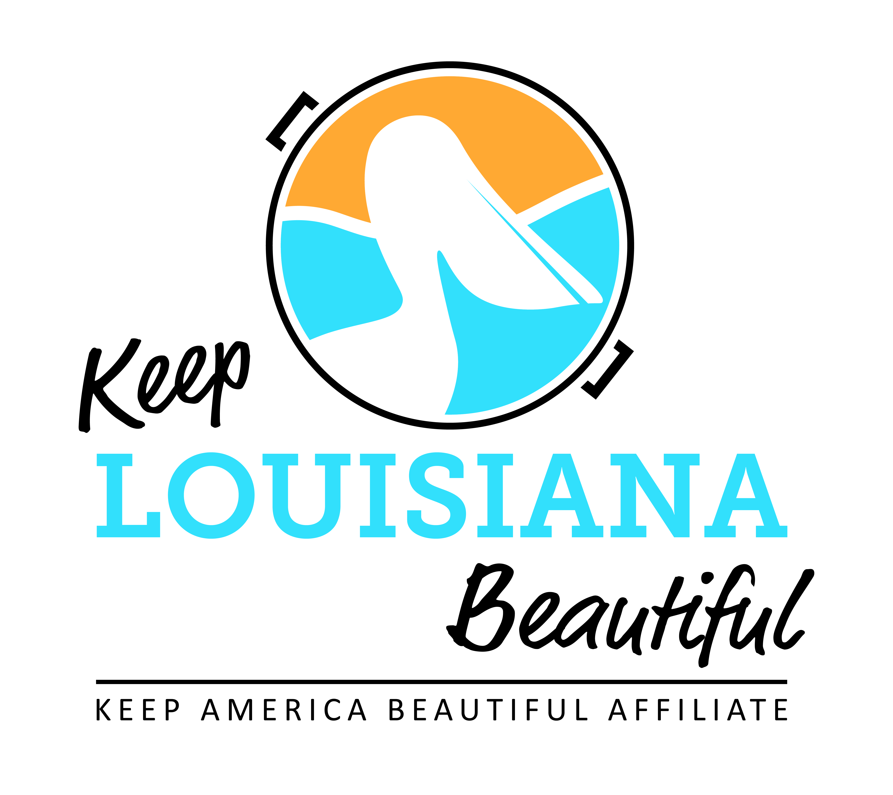

2023-24 GRANTS PROGRAM

- Affiliate Grants
Applications and reporting: Affiliate Resource Center, KLB’s website
Application Deadline: April 15
Eligibility: Must be an active affiliate and received COE at the time of application
1. Affiliate Program Grant – Reimbursement grant up to $2,500; a mini HCG.
2. **Cleanup Supplies Affiliate Grant – Affiliate may receive gloves, grabbers, safety vests, t-shirts and trash bags.
3. Trash Receptacle Affiliate Grant – Affiliate may receive up to five trash receptacles and KLB logo signs to be place on public property.

- Healthy Communities Grant
LOI Deadline: March 8
Application Deadline: April 15

- If project or program is selected, an invitation to submit a full grant application will be emailed by March 17.
- Grants available to all non-profits, schools, universities, governmental agencies, and KAB affiliates in Louisiana.
- Reimbursement grant amount $2,500 to $8,000.
- Highly competitive, open to all non-profits, schools, universities, and government agencies in LA.
**An affiliate that has received this grant two consecutive years in a row is not eligible to apply until the next grant cycle.
Please read carefully the eligibility, requirements, and terms of agreement carefully before applying. An affiliate must be active and in Circle of Excellence at the time of application before applying for grant.

Circle of Excellence Requirements
Submit the Affiliate Impact Report due August 1.
Attend the Annual KLB State Conference in October by an affiliate representative.
Attend one of the KLB Regional Meetings in June by an affiliate representative.
Participate in at least 3 of the 6 bi-monthly affiliate conference calls by an affiliate representative.
Participate in Love the Boot Week.
Conduct least one litter removal, waste reduction and beautification event or project each year.

