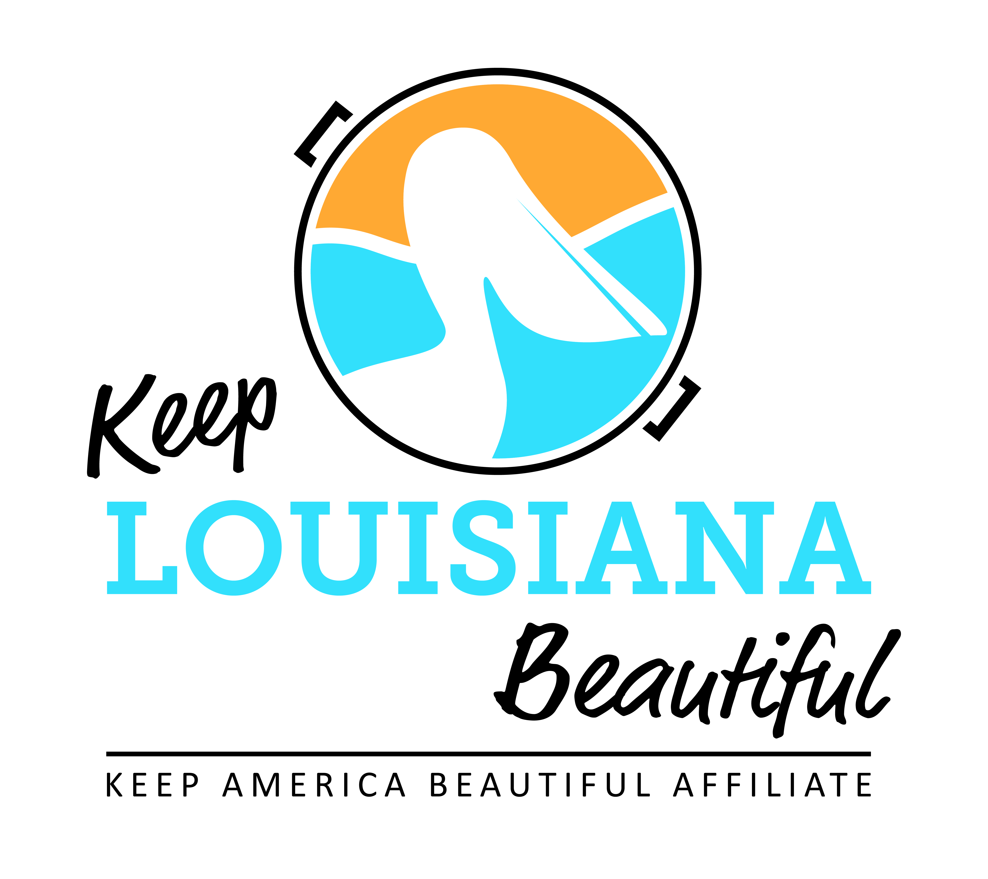

Affiliate Zoom Conference Call Agenda
Thursday 9/15/22
8am or 3pm
Duration: 1 Hour
Link to meeting emailed one week prior.

- Shreveport Green’s Urban Farm Presentation – Lauren Jones, Urban Farm Director, Shreveport Green
  - Affiliate Sharing

- New KLB Office Address and Phone Number
  - Address: 111 N. Causeway Blvd, Suite 104, Mandeville 70448
  - Phone: 985-778-0067

- 2022 State Conference and Everyday Hero Awards Luncheon
  - Tuesday, October 11 and Thursday, October 12, Baton Rouge Hilton Capitol Center
- Conference Agenda
- Circle of Excellence award presentations, Tuesday, October 11, 12:15pm to 1:00pm
- Everyday Hero Awards luncheon, Wednesday, October 12, 12:30pm

- Governor’s Task Force on Litter and Beautification Recommendations
  - KLB’s New Initiatives

II. KAB Updates
- Regional Director: Isaac Nicholson, inicholson@kab.org, Phone: (704)604-4114
- KAB’s New President: Jenny Lawson, jlawson@kab.org
- National State Conference: February 20-22, 2023, Washington D. C. Hilton

III. Next affiliate conference call 11/17/22

