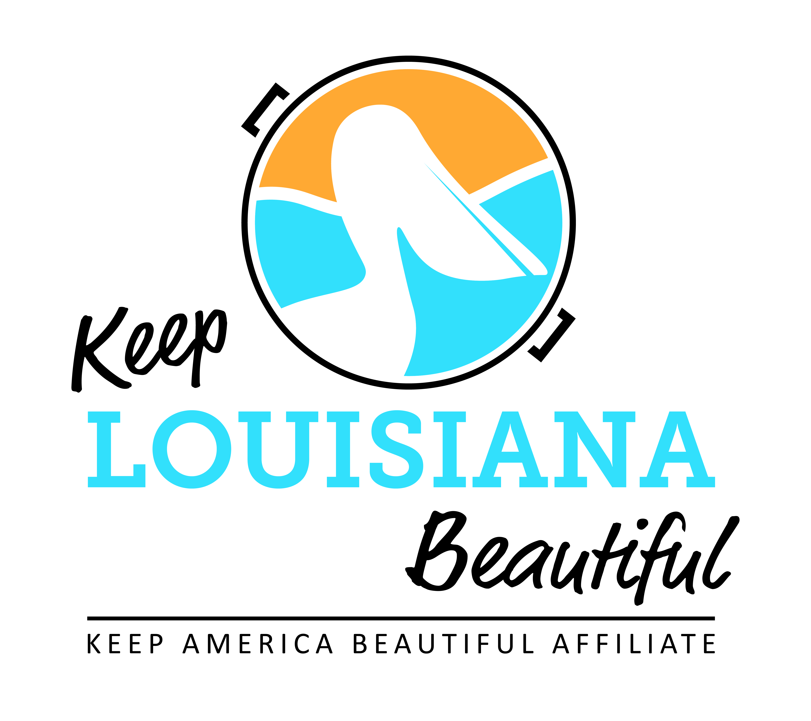

Affiliate Meeting Agenda
Thursday 7/21/22
8am or 3pm
Duration: 1 Hour
Join Zoom Meeting
https://us02web.zoom.us/j/89051128134
Meeting ID: 890 5112 8134
Dial in #: 1-301-715-8592 or 1-312-626-6799
I. KLB Updates

- 2022-23 Affiliate Bi-Monthly Meeting Dates - Cabell
- 2022: July 21, September 15, November 17
- 2023: January 19, March 16, May 18
- Third Thursday every other month at 8am and 3pm

- Grants Announcements - Cabell
- 2022-23 Healthy Communities Grant recipients
- 2022 Trash Receptacle Affiliate Grant recipients
- 2022 Cleanup Supply Affiliate Grant recipients

- KLB State Conference:
- October 11 and 12, Baton Rouge Hilton Capitol Center
- Everyday Hero Awards, October 11

- Affiliate Impact Report due August 1
- Summary of affiliate activities, events and outcomes from July 1, 2021 – June 30, 2022
- Report located on Affiliate Resource Center
- Circle of Excellence requirement

- Governor’s Task Force on Litter and Beautification Update – Susan Russell

- Love the Boot Day every 4th Saturday – Spread the Word, Not the Litter
- Take the Pledge https://www.cognitoforms.com/KeepLouisianaBeautiful1/PledgeToParticipateIn4thSaturdayCleanups

II. KAB
- Isaac Nicholson, Regional Director, inicholson@kab.org, 203-659-3010

III. Next affiliate conference call 9/15/22

