Community Litter Survey Guide
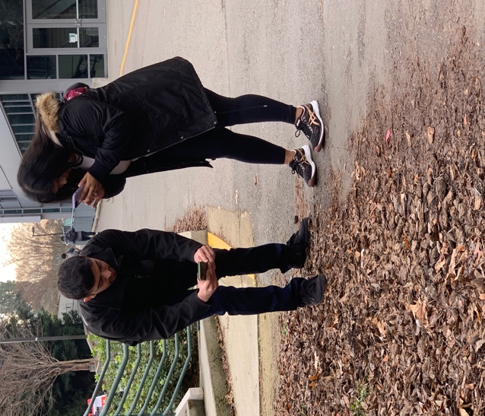
Table of Contents

Introduction 1
Litter Survey Process 1
Step One: Coordinator and Team Selection 1
Step Two: Tour Community/Planning 2
Step Three: Preparing for Litter Survey 3
Step Four: Conducting Litter Survey 4
Conclusion 8
Litter Scale 9
Litter Survey Pre-Litter Survey Planning Checklist 10
Litter Survey - Planning Checklist 11
Training and Safety Procedure 12
Determining Area and Mapping Locations 13
Frequently Asked Questions 14
Litter Survey Tally Sheet 16
Litter Survey Summary Form 18
Community Assessment Tool (Optional) 19
Suggested Uses for Litter Survey (Optional for Internal or External Uses) 20

For More Information Contact

Keep Louisiana Beautiful
https://keeplouisianabeautiful.org

LITTER SURVEY GUIDE

Introduction
A litter survey is a process of identifying, assessing, and documenting litter conditions in pre-determined areas. A litter survey includes assessing the litter conditions in and around the parish, city, or community and ranking the litter condition for annual comparison. According to Louisiana statutes, litter consists of the throwing, discarding, placing, dropping, or allowing the escape of items. The litter may be disposable packages, containers, cans, bottles, cigarettes, cigarette butts, cigar or cigarillo tips, building materials, or similar printed materials, e.g., pamphlets or newspapers.

The initial survey establishes a litter baseline and will assist in identifying types of products littered and location to develop a plan of action for reducing litter and littering behavior. The litter measurement tool results will direct the institution in developing strategies to address the litter situation. The ultimate goal is reducing litter and changing behaviors through the use of intervention, awareness, and action, which may include:
- identifying specific product types for reduction, e.g., installing water refill stations to reduce single-use plastic containers
- implementing appropriate infrastructure interventions, e.g., placement of trash and/or recycling containers,
- designing and conducting a targeted litter awareness campaign, or
- participating in cleanup events.

This survey design provides an essential requirement for consistent implementation across the state. The survey presents a qualitative (visual) and quantitative (numeric) examination of the litter conditions. The institution will schedule a follow-up survey at approximately the same time each year to measure success and plan for the following year. The survey may integrate into a wide range of classroom or academic instruction, from environmental science to social studies to mathematics.

Litter Survey Process
The litter survey process includes four steps:
1. Coordinator and Team Selection
2. Tour of Community/Planning
3. Preparing for Litter Survey
4. Conducting Litter Survey, including Cleaning Up

Step One: Coordinator and Team Selection
The first step in the litter survey is identifying a litter survey team coordinator and selecting survey team members. The coordinator may be a government staff, civic leader, teacher/professor, or student. The community should recognize the coordinator with the authority and responsibility to complete the litter survey. The coordinator's commitment will be 10-12 hours to complete the four-step process and report the results.

A typical team will consist of 3-4 members, which may be elected officials, community leaders or staff, students, or a combination. The time commitment varies with a minimum of 3 hours for the litter assessment only or 4-6 hours for location walk-through, survey assessment, and cleanup. A few possibilities to consider when seeking team members:
- Elected officials
- Solid Waste Department or Contractor
- Parks/Facility Management Department
- Environmental Science/Political Science/Sociology Professor (class project)
- Student organization (service project)

The coordinator may choose a variety of ways to reach out to possible team members, including but not limited to:
- Email or phone call to staff or faculty
- Notice in community communication/newsletter
- Outreach to student organizations
- Social media post

Individuals selected for the team must be motivated, interested in, and committed to gathering facts about litter and litter conditions. The process is flexible to permit the survey's completion by staff, students, or class project.

Step Two: Tour Community/Planning
The coordinator will conduct a tour of the community to plan the survey. During this planning process, the coordinator should take notes and map sites for the litter survey identifying the specific areas for conducting the litter survey and evaluating the conditions. During the initial tour, the coordinator will observe current conditions, including existing infrastructure, e.g., storm drains, trash cans, etc. The coordinator is not looking for the cleanest or dirtiest areas but planning a survey using the locations and guidelines to identify different types of sites.

Locations
While the coordinator or team has flexibility for the site selections, the goal is to identify areas across the whole community using specific land-use types. A grid system dividing the community into sections provides a general way to ensure representation. An alternative may be using roadways or political or school zones to divide the community. The litter survey includes ten (10) sites randomly selected from the following land uses and locations:
- Entrance roadway, a main road into the jurisdiction (2)
- Residential roadway
- Downtown or main street business area
- Retail location (not downtown)
- Gas or gas/convenience store
- Restaurant or fast food
- Park, open space, or waterway
- Tourist site
- Public building, e.g., school or government

In the planning phase, the coordinator will consider if the approximate 1,000 square feet of litter assessment area is easily accessible. The coordinator is not required to measure the sites during the planning phase but should be evaluating each location to ensure that the space is available for the litter assessment. Depending on the location layout, the recommendation for the assessment area is either a rectangular or circular area (p.16 for more detail):
  - 100 feet by 10 feet = 1,000 square feet OR
  - 36-foot diameter circle = 1,067 square feet

At the end of the tour, the coordinator will have identified the ten (10) locations. The coordinator should have a map showing each site and the possible 1,000 square feet litter assessment area. Additionally, the coordinator may create a written document with the location or building name, address, and notes on access or parking, if applicable.

Step Three: Preparing for Litter Survey
After identifying the survey locations, the coordinator and team will finalize preparations for the litter survey, including setting a date, purchasing supplies, and designating tasks.

Date and Time Commitment
The recommendation for completing a litter survey is a midweek day (e.g., Tuesday-Thursday). Avoid days of the week when there has been higher than usual activity, sporting events, or other high traffic times. The litter survey may occur at any time, but for best results, plan at a time of year when the survey may be repeated annually.

The time commitment for the coordinator and team varies. A general outline of the time commitment includes:

Coordinator (10-12 hours)
- Identifying team members
- Organizing community tour and location determination
- Communicating with the team
- Administering activities on the day of the litter survey and coordinating team tasks
- Documenting results

Team (4-6 hours)
- Participating in community tour and location determination (optional)
- Conducting litter survey and implementing assigned tasks (outlined in procedure steps)
- Sharing experiences and evaluating process

Supplies
Before conducting the litter survey, the coordinator will secure the supplies needed. The items may be available from the local government or purchased. Supplies recommended include:
- Tape measure, measuring wheel, or a pre-cut rope
- Litter Tally Sheet (p.17-18) minimum 10 copies
- Litter Scale sheet (p. 9) minimum 1 copy
- Pencils or Pens
- Phone/tablet/computer, with a camera to enter data in the field
- Phone for contacting the team and emergency assistance, if needed
- Hand sanitizer, depending on access to water to wash hands if cleaning up litter
- First aid kit

If a cleanup will be conducted at the litter assessment sites, the coordinator will collect cleanup supplies, which may include:
- 3-4 buckets or trash bags
- Litter tools, e.g., grabber
- Reusable or disposable gloves
- Masks or face covering

Step Four: Conducting Litter Survey
Pre-Survey Team Communication
Before conducting the litter survey, the team implementing the survey should receive a message outlining any requirements and safety considerations. The coordinator should inform the team about time and physical requirements, including the potential of walking and bending to collect litter. Additionally, the coordinator will notify the team of any necessary paperwork to be completed before or at the start of the litter survey (e.g., liability waivers or photo releases).

Sharing Safety Considerations
Litter survey participants must follow instructions from the coordinator. For the litter assessment, the team must be aware of surroundings including but not limited to observing traffic and the physical terrain of each site. While the cleanup process recommendations include using a litter grabber tool or gloves to limit touching materials, personal protection items further reduce exposure to waste items. Clothing recommendations include:
- Comfortable shoes for walking on uneven surfaces
- Hat
- Clothing appropriate for bending to collect litter from the ground

Participants may observe a variety of items within the litter survey that might be a hazard especially if conducting a cleanup, and team members must safely handle the litter with proper tools and protections. Litter surveyors may come across biological or physical hazards. The following risks are possible:
- Wet (contain liquid), dusty, or moldy material
- Sharp objects, e.g., broken glass or used needles
- Toxic or corrosive waste
- Live and dead animals or parts of animals or insects, including mosquitos, cockroaches, ticks, and fleas
- Body fluids
- Other potentially hazardous natural and/or manufactured materials

The coordinator should provide safety information specific to the community. The pre-survey communication should inform the team about liability waivers, if applicable, and that training will be included before beginning the actual survey.

Litter Survey Procedure By Steps
As an overview, the team will work together and move from location to location to conduct the Litter Survey and may wish to coordinate vehicle transport between locations. The recommended process has one person walking and calling out the type of litter. The second person will record the data on the tally sheet or add data to the online app or tool if applicable. The second person may take photos of the litter document conditions for the final report and compare sites in the future. Additional team members will collect litter after the litter rating is determined and share updates on litter counts or types of litter collected to ensure accurate reporting for each location.

On the day of the litter survey, the team will follow these steps to conduct the litter survey. The schedule should consider 4-6 hours, including training and cleanup.
- Materials
  - Collect and verify supplies (page 4)
- Team Safety Training (confirm details above)
  - Safety reminders, including wearing gloves when picking up litter
  - Review clothing recommendations
  - Cover any specific community safety requirements
  - Paperwork, e.g., liability waiver and photo release, if applicable
- Assign Team Duties
Team members may have more than one duty, depending on the number of team members. Consider switching or rotating team assignments at each site to offer experience with each task, e.g., the recommended process has one person measuring the area, one person walking and calling out the type of litter; one person recording the data on the tally sheet or, if applicable, using online app or tool and taking photos; and one person conducting the cleanup of any litter.
  - Measure area
  - Documenting litter conditions using the Likert scale
    - 1=No Litter
    - 2=Small Amount Litter
    - 3=Littered (easily seen in the area)
    - 4=Excessive Amount Litter
  - Identify the type, size, and amount of litter
    - Paper
    - Plastic
    - Glass
    - Metal
    - Organics
    - Mixed-material
  - Cleanup (optional)
    - properly dispose of litter by either placing it in waste container or recycling bin
- Mapping Process
  - Plot locations with GPS coordinates or mark them on a map. Use a free online mapping app or litter survey app for coordinates. This mapping is essential for future litter surveys to be conducted at the same locations for following up annually.
  - Consider a grid overlay to select locations and select a minimum of one (1) site location in each grid area.
- Site Measurement
  - The litter assessment area is approximately 1,000 square feet. Either a circle or rectangle spaced area, depending on site conditions.
    - 100 feet by 10 feet = 1,000 square feet (Exhibit 1)
    - 36 foot diameter circle = 1,067 square feet (Exhibit 2)
Depending on the site's configuration, the team may adapt to another length or width to reach 1,000 square feet. In a parking area, the team may consider 50 feet by 20 feet or 40 feet by 25 feet = 1,000 square feet to survey parking spaces, typically 18 feet in length by 9 feet wide, plus pedestrian and vehicle area surrounding a parking space.

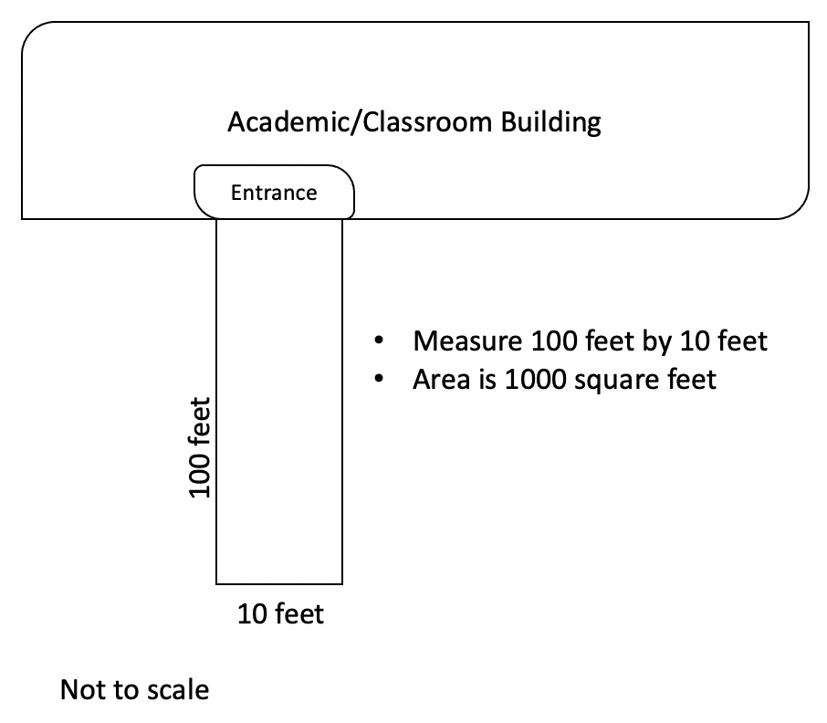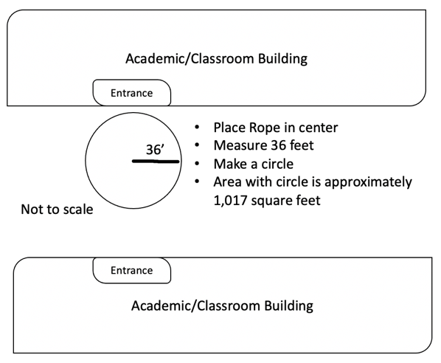

Exhibit 1 Exhibit 2

  - Have a volunteer demonstrate how to use measurement to create the correct observation area. Use a smartphone, GPS unit, or tablet to determine the GPS coordinates.
  - Site-specific considerations:
    - Entrance roadway: Select a high traffic area identified as a primary entrance to the parish/city/town
    - Residential road: Select an area that is residential in nature and typical of the jurisdiction, e.g., most common housing type or design
    - Downtown/Main Street Business: Select area outside the building along walkways or between structure and parking areas (results mid-block may be different from a corner, and the team may wish to conduct more than one site or note differences if any appear)
    - Retail area: Select area outside the building along walkways or between structure and parking areas
    - Gas station or gas/convenience store: Select area outside the building along walkways or between structure and parking areas (results mid-block may be different from a corner, and the team may wish to conduct more than one site or note differences if any appear)
    - Restaurant or fast food: Select an area near the entrance to the dining area and include an outdoor dining area, if applicable.
    - Park, open space, or waterway: Select high traffic area walkway or congregation area
    - Tourist area, e.g., historic site, hotel, or location advertised as a place to visit: Select an area with parking and pedestrian and vehicle access or a walkway
    - Public building, e.g., school or government: Select area outside the building along walkways or between structure and parking areas

The survey area may vary to meet the 1,000 square feet, e.g., a rectangular area or a circular area. (See Exhibits 3 and 4). The square footage should include the street curb area, sidewalk, and vegetation area. A sidewalk width range from 4 to 6 feet, e.g., a 200 feet long by 5 feet meets the 1,000 square feet requirement.

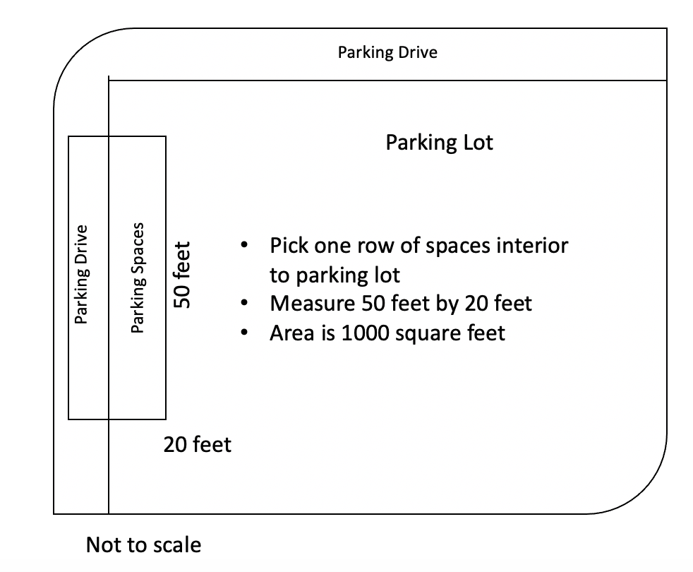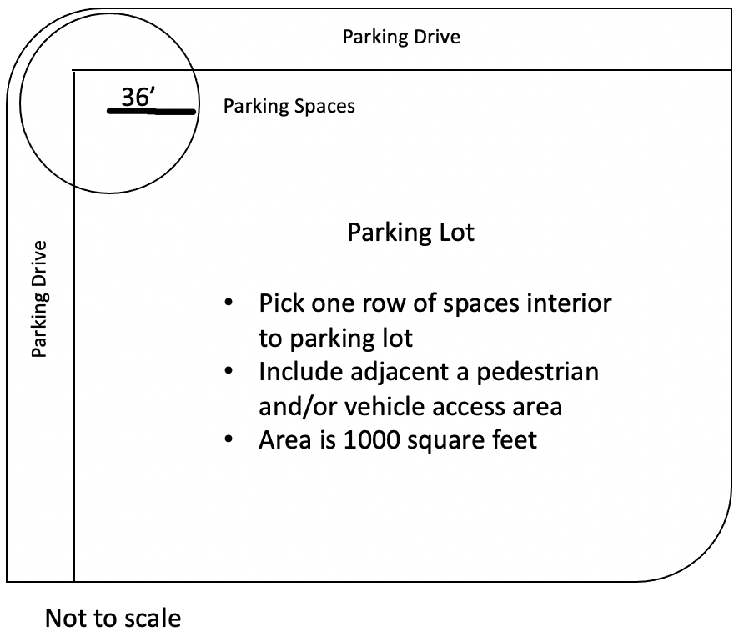
Exhibit 3 Exhibit 4

- Litter Assessment
  - Provide team with Data Sheet
  - Discuss the scoring system. In determining the litter condition, consider how visible the litter is on first observation and how frequent or consistent is the amount of litter. The team will review the area and then rank using the 1-4 Likert scale:
1=No Litter
2=Small Amount Litter
3=Littered (easily seen in the area)
4=Excessive Amount Litter
  - The recommended process:
    - One person walking and calling out the type of litter
    - A second person will record the data on the tally sheet or in online app or tool.
    - A third person may take additional photos of the overall site to document conditions to use in litter plan development and compare conditions in the future.
    - A fourth person cleans the location with the assistance of others as the survey is completed. The cleanup of the area may occur either simultaneously with identifying litter or at the end of the area's survey.

Concluding Litter Survey
At the end of the litter survey, the coordinator should ask the team about the experience and discuss their analysis of litter conditions. These questions may assist in communicating the results of the litter survey. Possible concluding questions:
- What surprised you about the litter survey?
- What intervention would reduce litter?
- How could an awareness campaign reduce litter and littering behavior?
- Does the placement of a container impact litter conditions?
- What recommendations do team members have to improve the litter survey process?

Data reporting
At the end of the litter survey, the coordinator collects tally sheets and confirms data entry into a spreadsheet or app. The litter survey data will assist the community in waste management/zero waste planning, sustainability activities, and cleanup efforts. The Affiliate Report includes the following information:
- Description of Team (Check all applicable)
  - Elected officials
  - Solid Waste Department or Contractor
  - Parks/Facility Management Department
  - Environmental Science/Political Science/Sociology Professor (class project)
  - Student organization (service project)
- Approximate Time to Plan and Complete Litter survey (# Hours)
- Describe the Location of Each Site and Litter Likert scale ranking
- Upload 1-3 pictures of a team conducting the survey

Conclusion
The litter survey results will assist the community in developing or enhancing strategies to reduce waste and litter. The survey’s primary purpose is to identify litter issues to educate and engage business owners and community leaders on environmental issues such as waste reduction, litter prevention, and marine debris that have long-term effects on our state and the Gulf of Mexico. The litter survey results will aid the community in understanding the extent of the litter problem. Additionally, the results may help reduce litter by better understanding the composition of litter and establishing ongoing education on the topic to target specific types of litter. The goal is to eliminate litter and promote proper waste disposal behaviors.

Litter Scale
1 | - Virtually no litter  - 1 or 2 small items under 4 inches in an area  - Generally tidy | 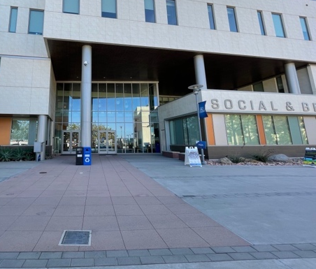
2 | - A small amount of litter  - Littered items do not continually grab the eye | 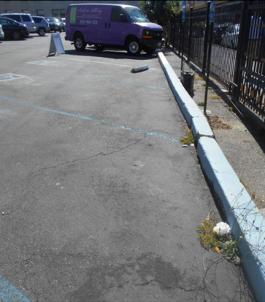
3 | - Visible litter catches your eye frequently  - Considerable effort to clean
4 | - A continuous and noticeable amount of litter  - Litter first thing noticed  - Strong impression of a lack of concern about litter | 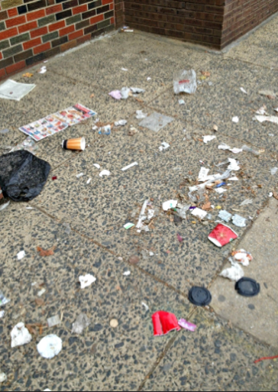

Litter Survey Pre-Litter Survey Planning Checklist
Task | Details | Date
Coordinator | Select leader for the litter survey
Team | Identify team members, e.g., staff or student project
Sites –Litter Survey | Identify locations  - entrance roadway into the jurisdiction  - residential road  - downtown or main street business area  - retail location (not downtown)  - gas or gas/convenience store  - restaurant or fast food  - park, open space, or waterway  - tourist site  - public building, e.g., school/government  Map infrastructure at locations, e.g., storm drains, trash cans, recycling receptacles, or similar
Schedule Date and Time | Check calendar for a midweek day
Supplies (purchase or verify) | See the detail list in the guide  - Measuring wheel, tape measure, or 100 feet of rope and marked at 36 feet  - Tape, flag, or cone to mark area  - 3-4 buckets or trash bags for cleanup  - Litter tools, e.g., grabber  - Reusable or disposable gloves  - Masks or face covering
Reminder to the team (1 and 7 days prior) | Send a message to the team with details on the litter survey
Waste disposal | Arrange to dispose of any litter collected during the survey

Litter Survey - Planning Checklist
Task | Details | Notes
Team Safety Training | - Safety reminders, including wearing masks, eye shields, and gloves, when applicable  - Paperwork, e.g., waivers, if applicable
Assign Team Duties | - Measuring area using either tape measure, measuring wheel, or rope  - Data collection on a tally sheet or app  - Litter identification  - Paper  - Metal  - Organics  - Glass  - Mixed-Materials  - Collecting litter  - Post data analysis
Data Finalization/Reporting | Enter data in applicable forms

Training and Safety Procedure
Note: This guide provides general suggestions only. The community must provide training specific to their jurisdiction. The information may serve as a script for sharing information with additional local details.

Overview of Litter Survey
A litter survey is a process of identifying, assessing, and documenting litter conditions in pre-determined areas. The standard definition of litter is throwing, discarding, placing, dropping, or allowing the escape of waste items in public spaces. During the survey process, volunteers will assess litter conditions at pre-determined locations. Volunteers will measure a 1,000 square foot area and then use a Likert scale to rate the amount of litter.

Potential Hazards
Participants may observe a variety of items within the litter survey that might be a hazard during the cleanup, and team members must safely handle the litter with proper tools and protections. Litter surveyors may come across biological and physical hazards. The following risks are possible:
- Wet (contain liquid), dusty, or moldy material
- Sharp objects, e.g., broken glass or used needles
- Toxic or corrosive waste
- Live and dead animals or parts of animals or insects, including mosquitos, cockroaches, ticks, and fleas
- Body fluids
- Other potentially hazardous natural and/or manufactured materials

Personal Protection
Litter survey participants must follow instructions by the coordinator. While the process recommendations include using a litter grabber tool to limit touching materials, personal protection items further reduce exposure to waste items. During the litter survey, team members may wear face masks, gloves, and eye protection, e.g., glasses, goggles, or shield. Clothing recommendations include:
- Comfortable shoes for walking on uneven surfaces
- Hat
- Clothing appropriate for bending to collect litter from the ground

General Safety Considerations
- Wash hands with soap and water for at least 20 seconds to 1 minute, or use an alcohol-based hand sanitizer if soap and water are not available

Liability Waiver
Before starting the litter survey, all team members must sign a liability waiver or other paperwork if applicable.

Determining Area and Mapping Locations
Rectangle
Recommended measurement is a rectangle with 1,000 square feet in area. Adjust the length or width to maintain the 1,000 square feet depending on the physical location.

Length: 100 feet
Width: 10 feet

Length: 50 feet
Width: 20 feet

https://www.calculateme.com/shape-area/rectangle/
https://www.sensorsone.com/length-and-width-to-area-calculator/

Depending on the site's configuration, the team may adapt to another length or width to reach 1,000 square feet. In a parking area, the team may consider 50 feet by 20 feet or 40 feet by 25 feet = 1,000 square feet to survey parking spaces, typically 18 feet in length by 9 feet wide, plus pedestrian and vehicle area surrounding a parking space.

Circle
Identify a center point and then make a circle with a 36 feet radius. The center point should be a minimum of 36 feet from a building. The total area within the circle is 1,046 square feet.

https://www.calculateme.com/shape-area/circle/

36’

Mapping and Coordinates
A map will assist in planning and conducting the litter survey and provide documentation of the sites for future assessments. Several apps and maps on phone and tablet will assist in identifying coordinates. On iPhone or Android phone or tablet:
- Open the Google Maps app
- Touch the screen and hold a finger on the location on the map
- A red pin appears
- Scroll up on iPhone to the bottom to see coordinates or on an Android search box to find the coordinates.
Another option is to enter the location/address into https://www.latlong.net/ and drag the pin to the site.

Frequently Asked Questions
Step One: Organization

Do all the litter survey team members need to be from the same group?
- No, the litter survey team may include anyone interested in participating. The guide offers suggestions for identifying team members.

Should we keep the names of the litter survey team?
- We recommend keeping a list of the litter survey team composition with the Litter Survey files/records. The material may be beneficial in conducting the Litter Survey in the future.

Step Two: Tour Community/Planning

- Do we need to identify locations from across the whole community?
The recommended location types, e.g., entryway, downtown, and gas station/convenience store, might be anywhere within the jurisdiction's defined boundary. The diverse locations provide flexibility for the selected sites from different areas. A grid system dividing the community into sections provides a general way to ensure representation from across the community. An alternative would be to use major roadways or political or school zones.

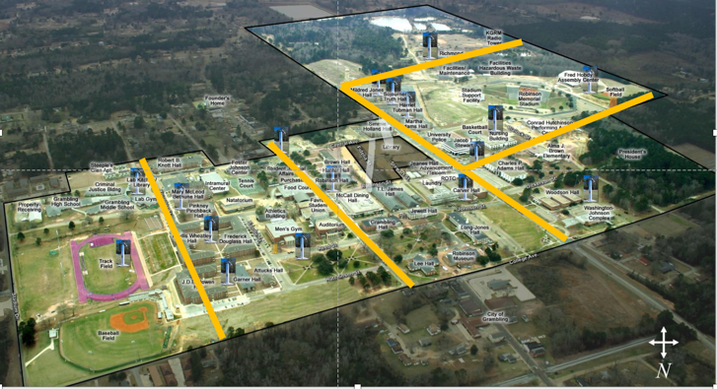
Grambling State University

What types of physical characteristics should we consider in selecting sites?
- In addition to randomly sampling across the community, the coordinator and team may want to look for storm drains and slopes for water flow. The site may or may not be near trash or recycling containers, but research indicates people are more likely to litter 29-30 feet from a container (Carson, 2021; Schultz et al., 2013).

What steps should we take when measuring litter at a building entry?
- The Litter Survey Team should conduct the measurement when building entry traffic is low, e.g., survey at 8:30 a.m. when class starts at 9:00 a.m. The team members should be aware of their surroundings and familiar with any emergency exit. The members should not obstruct walkways unnecessarily and attempt to look down at litter while at the same time checking for pedestrians and vehicles.

Step Three: Preparing for the Litter survey

Do we need to use the same measurements at all sites?
- The recommendation is to use an approximate 1,000 square foot area for consistency. The shape of the survey area may vary depending on the terrain or physical characteristics of the survey location.

Should team members wear specific clothing?
- Yes. A list of clothing recommendations is on page xx. The team should wear clothing to protect themselves from potential exposures, including closed-toe shoes and long sleeves and pants.

Step Four: Conducting the Litter Survey and Reporting

Should all sites be observed on the same day?
- Yes, all surveys should occur on the same day and within a continuous number of hours, e.g., Wednesday between 8:30 a.m. and 11:30 p.m.

Should the team collect litter?
- Yes, collect the litter and report the number of bags.

Litter Survey Tally Sheet
Contact Name:
Phone/Email
Location:  - entrance roadway (2)  - residential road  - downtown or main street business area  - retail location (not downtown)  - gas or gas/convenience store  - restaurant or fast food  - park, open space, or waterway  - tourist site  - public building, e.g., school/government |  | Litter Survey Number __________  1=No Litter  2=Small Amount Litter  3=Littered (easily seen in the area)  4=Excessive Amount Litter
Material Type | Count (estimate) |  | Source/Notes
PAPER
Cardboard/Box
Envelopes and junk mail
Food packaging
Napkins/Towels
Newspaper
Office/writing paper
Paper bag
Paper cup
Paper plates/food service
Receipt
Small paper pieces
Other
TOTAL PAPER
METALS
Aluminum can, beer
Aluminum can, energy drink
Aluminum can, soft drink
Aluminum can, water
Cap or Tab
Food Packaging/Aluminum foil
Small metal pieces
Other
TOTAL METAL
ORGANICS
Food item – apple core
Food Waste – prepared food
Other
TOTAL ORGANICS
Litter Survey Tally Sheet
Material Type | Count |  | Source/Notes
GLASS
Glass beverage bottle, alcohol
Glass beverage bottle, water/tea
Small glass pieces
Other
TOTAL GLASS
MIXED MATERIALS (combo plastic, paper, and/or metal materials)
Candy/Gum wrapper
Condiment Package (ketchup)
Drink carton (milk)
Drink box (aseptic box)
Food packaging
Cigarette/cigar butt
Other
TOTAL MIXED MATERIALS
PLASTIC
Bag
Beverage bottles – soft drinks
Beverage bottles - water
Cap
Cup
Film/wrap
Food containers - foam
Food containers - #1 or 2
Food packaging
Lids
Straws
Utensils/Cutlery (fork, spoon)
Zipper/sandwich bag
Small plastic pieces
Others
TOTAL PLASTICS
OTHER ITEMS
Clothing or pieces
Hygiene Items
Other
TOTAL OTHER ITEMS

Litter Survey Summary Form

Town/City/Parish:

Litter Survey Coordinator Name:

Email: Phone:

Date Litter Survey Completed:

Time to Organize/Plan (# Hours): Time to Conduct (# Hours):

How many people were on the Litter Survey Team?

Description of Litter Survey Team (Check all Applicable)
- Elected officials
- Solid Waste Department or Contractor
- Parks/Facility Management Department
- School Service-Learning Department/Division
- Environmental Science/Political Science/Sociology Professor (class project)
- Student organization (service project)
Specific Name of Organization(s):

Describe the 10 Sites and Litter Ranking
Location | Litter Ranking 1-4
Entrance roadway #1
Location:
Entrance roadway #2
Location:
Residential road
Location:
Downtown or main street business area
Location:
Retail location (not downtown)
Location:
Gas or gas/convenience store
Location:
Restaurant or fast food
Location:
Park, open space, or waterway
Location:
Tourist site
Location:
Public building, e.g., school/government office
Location:
# Bags of overall litter removed

Community Assessment Tool (Optional)

Scorer Name: _________________________________ Date: _____________________

Location (provide specific and check type below)
- entrance roadway (2)
- residential road
- downtown or main street business
- retail location (not downtown)
- gas or gas/convenience store

- restaurant or fast food
- park, open space, or waterway
- tourist site
- public building, e.g., schools or government offices

Overall Appearance Condition Score (Place X by your overall location score)
- Excellent - appealing with no disrepair to buildings, signs, or infrastructure issues
- Good - acceptable with minimal disrepair to buildings, signs, or infrastructure issues
- Fair – noticeable issues with litter and disrepair to buildings, signs, or infrastructure issues
- Poor – considerable litter, dilapidated structures, signs, or infrastructure issues

Litter Condition Score (Place X by your overall location score)
  - Excellent – no litter or minimal litter
  - Good – a small amount of litter that does not continuously catch your eye
  - Fair – litter that continuously catches your eye
  - Poor – heavy litter, large items, unkempt area

Litter Source (Estimate source, either intentional or unintentional

Sources of Litter | Percentage | Intentional or Unintentional
Business (dumpster or lack of receptacle)
Construction or demolition
Loading area or dock
Households (residential trash bags or cans)
Motorists (including boaters)
Hauling or uncovered vehicle
Pedestrians
Other
Total = 100 | 100

Are trash receptacles? ( ) adequate ( ) inadequate ( ) covered ( ) overflowing

Are recycling containers? ( ) adequate ( ) inadequate ( ) covered ( ) overflowing

Are dumpsters? ( ) screened ( ) visible ( ) clean ( ) overflowing

Comments (e.g., litter at the intersection or dilapidated signs):

Suggested Uses for Litter Survey (Optional for Internal or External Uses)
The Litter Survey results have numerous uses. For immediate use, the data may be included in a press release or article for distribution on litter conditions and to share involvement with Keep Louisiana Beautiful. The data may be compiled for a report to elected or appointed officials to address litter conditions or develop a comprehensive plan to address litter, waste, and related topics, including recommendations on ways to eliminate waste and change littering behaviors.
A report should generally have the following sections:
Introduction: Start with a brief 1-2 paragraphs outlining what you did, what you found, and recommendations
Method: Describe the steps to complete the litter survey in 1-2 paragraphs, including details relating to team composition, locations, litter ranking, and types of litter found
Results and Visuals: Show graphs and tables, and numbers, including photographs
Discussion: Identify your most common litter item removed and challenges for preventing littering behavior. Identify your biggest challenge in reducing a specific litter type or single-use disposables (SUD).
Conclusions/Recommendations: What was your overall impression of litter and waste, and what can you do to reduce the amount of litter, e.g., placement containers, how to eliminate commonly littered items, or persuasion efforts to increase awareness of litter and littering behavior?
Future use and follow-up surveys:

How have the community’s efforts changed operations to effect positive change on litter reduction over the last year?

Identify your greatest success in litter removal and prevention.

Identify your biggest challenge in reducing a litter item or type.

What strategies has your community put in place to reduce waste and litter?

