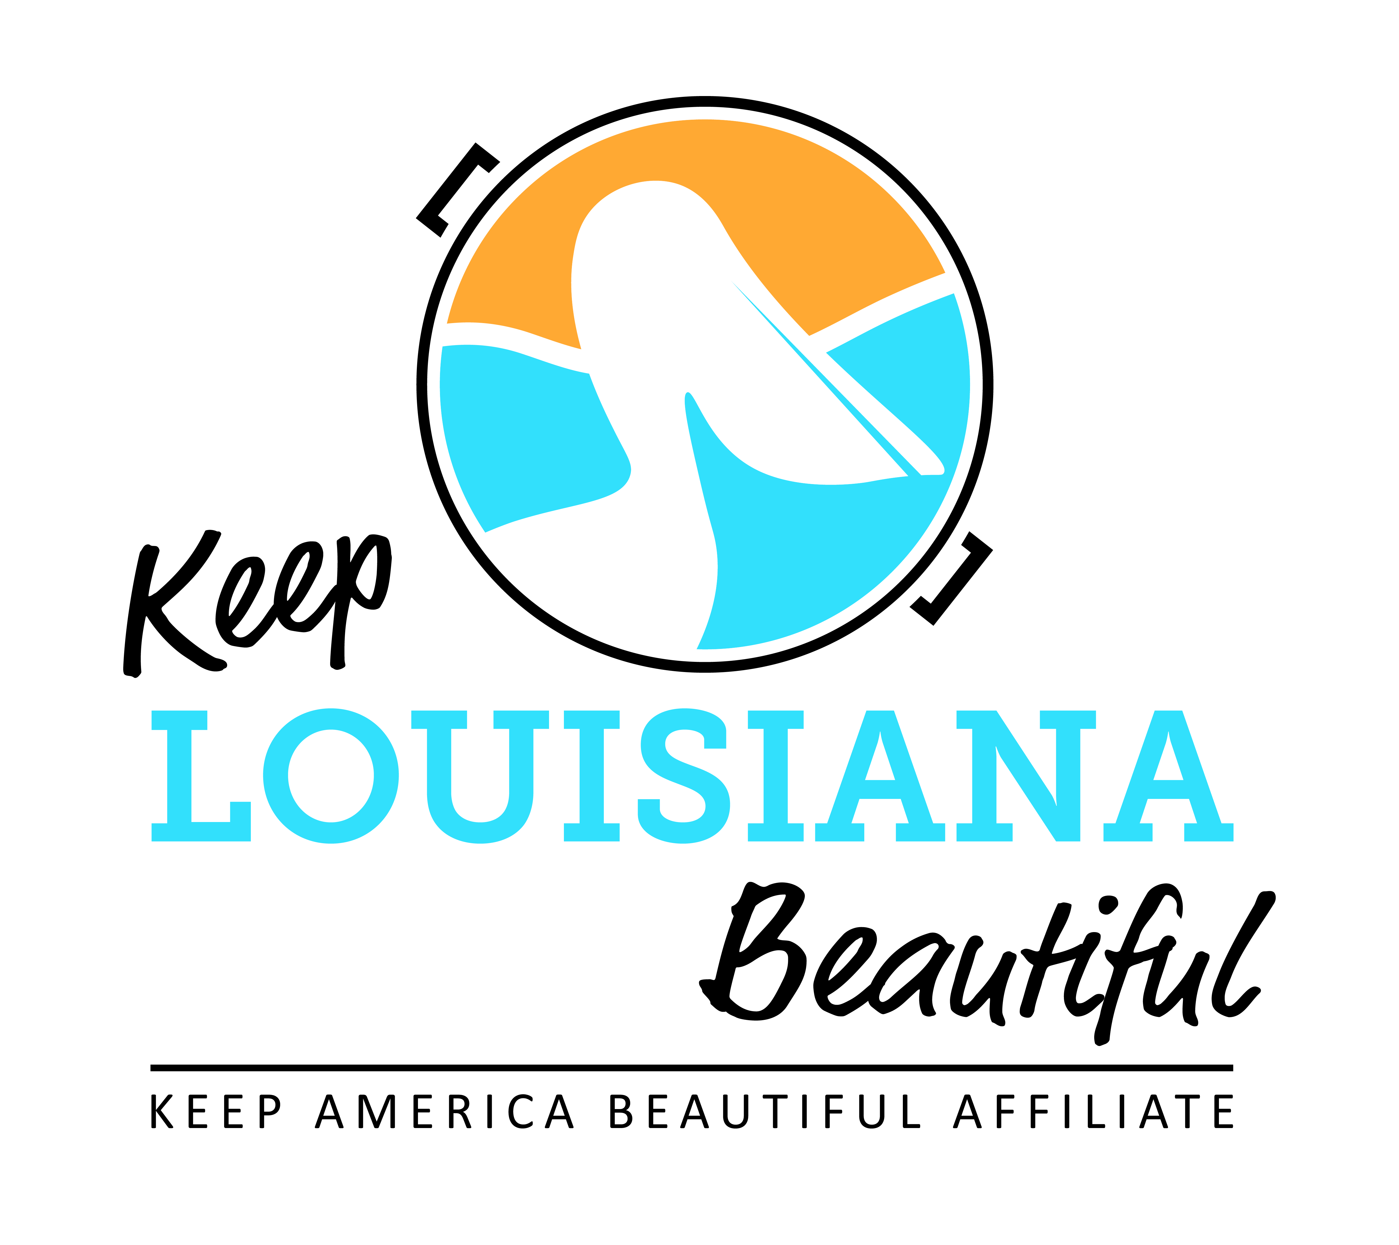

Affiliate Meeting Agenda
Thursday 3/17/22
8am or 3pm
Duration: 1 Hour
Join Zoom Meeting
https://us02web.zoom.us/j/89051128134
Meeting ID: 890 5112 8134
Dial in #: 1-301-715-8592 or 1-312-626-6799
I. KLB Updates

- Affiliate Networking and Sharing
- Prison Recycling Program – Lynn Bryan, Keep Bossier Beautiful

- Grants – Cabell M.
- Affiliate Grants – Online applications accepted through April 15
  - Cleanup Supplies Grant – *Please note an affiliate that has received this grant for two consecutive years is not eligible to apply this year. The affiliate must take a year off from this grant cycle before applying again.
  - Program Grant
  - Trash Receptacle Grant
  - Environmental Education Grant
  - Applications located on the Affiliate Resource Center

- 2022 Love the Boot Event: April 18-24, 2022 – Susan R.
- Litter Supply Kit
- Love the Boot Influencer Program
- Media Campaign: Let Your Light Shine

- Litter Abatement Task Force Update – Susan R.

- Legislation – Susan R.
- Current Litter Bills

II. KAB Updates – Isaac Nicholson, Regional Director, Keep America Beautiful
- Isaac Nicholson, inicholson@kab.org, 203-659-3010

III. Next affiliate conference call 5/19/22

