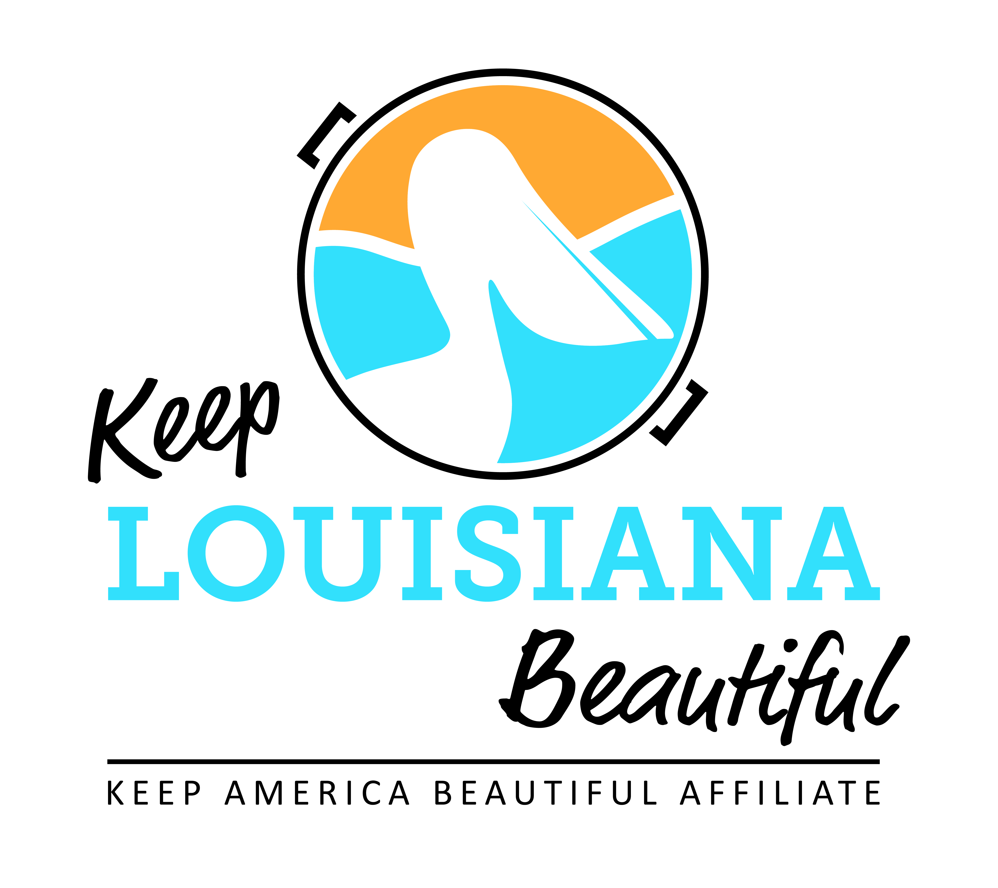

Affiliate Zoom Conference Call Agenda
Thursday 9/16/21
8am or 3pm
Duration: 1 Hour
Link to meeting emailed one week prior.

I. KLB Updates

- 2021 State Conference and Everyday Hero Awards Luncheon (In-person)
  - Wednesday, October 13 and Thursday, October 14
  - Baton Rouge Hilton Capitol Center
- New conference format
- Everyday Hero Award nominations due September 24

- 2022 Love the Boot Event and Other Events

- Extended Time of Affiliate Sharing

II. KAB Updates
- National Conference November 15-17, Washington Hilton, Washington DC
- Regional Director: Grace Keegan, gkeegan@kab.org, 203-659-3032

III. Next affiliate conference call 11/18/21

