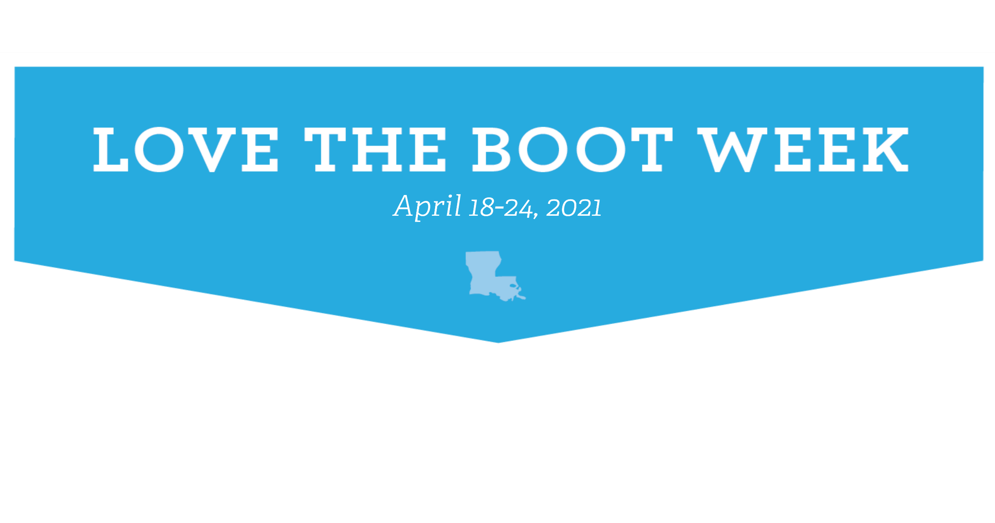
Event Liability Release and Photo Authorization Form

Project: | Date:

The Volunteer understands that he/she is engaging in activities that may expose him/her to dangers both from known risks and unanticipated risks. By signing this form the Volunteer discharges and holds harmless [INSERT COMPANY/ORGANIZAITON/AFFILIATE NAME], and its representatives from any and all liability, claims, losses, suits, damages, and demands of whatever kind or nature arising or resulting from property damage, bodily or personal injury and/or death that may be caused by [INSERT COMPANY/ORGANIZAITON/AFFILIATE NAME], and its agent’s negligence or otherwise.

By signing this form, the Volunteer also understands that [INSERT COMPANY/ORGANIZAITON/AFFILIATE NAME], and its partners, and affiliates may use all photographic images, video or audio recordings, video or audio reproductions, films, radio or television broadcasts and any other reproductions of the activities without limitations. Permission is granted for use in any medium now known or hereafter developed, including printed media, video, still photography and the Internet.

 | Name | Address, City, State, Zip | Email | How did you hear about us?
1
2
3
4
5
6
7
8
9
10
11
12
13
14
15
16
17
18

