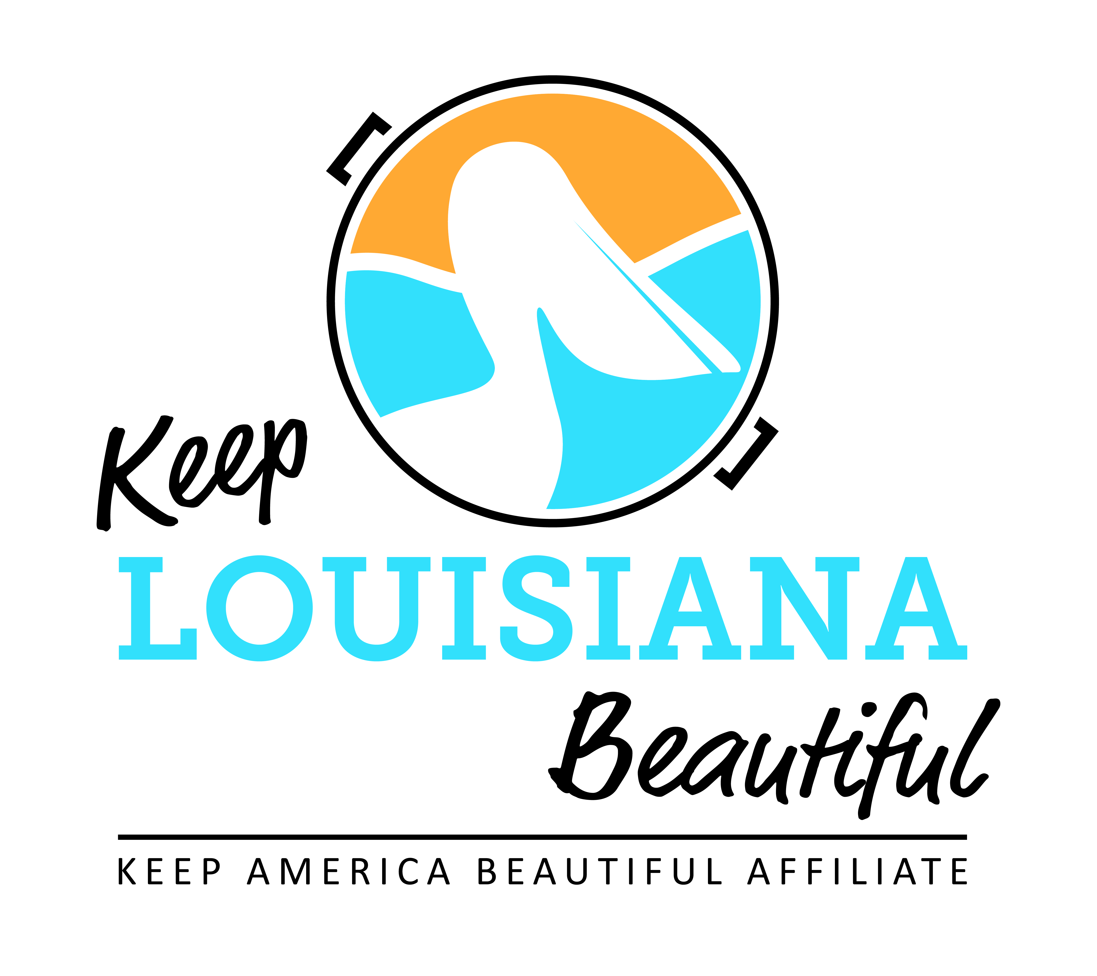

Affiliate Zoom Conference Call Agenda
Thursday 3/18/21
8am or 3pm
Duration: 1 Hour
Link to meeting emailed one week prior.
I. KLB Updates
1) Grants
- Affiliate Grants – Applications deadline April 15
  - Cleanup Supplies Grant – *Please note an affiliate that has received this grant for two consecutive years is not eligible to apply this year. The affiliate must take a year off from this grant cycle before applying again.
  - Program Grant
  - Trash Receptacle Grant
  - Environmental Education Grant
  - Applications located on the Affiliate Resource Center

2) Grant Reporting
- Cleanup Supply and Programs Affiliate Grant reports due on or before May 1, 2021
- Reports located on Affiliate Resource Center

3) Affiliate Regional Meeting (Virtual) – Wednesday, June 16, 9am -12pm
- Registration required
- Circle of Excellence requirement

4) Impact Card and Affiliate Impact One-Pager – Christal White

5) Funding Status - Susan Russell

II. KAB Updates
- Check Affiliate e-newsletter and KAB’s Dashboard for all updates
- KAB contact for Central Region: Grace Keegan gkeegan@kab.org
Phone: 203.659.3032

III. Affiliate Updates

IV. Next affiliate conference call 5/20/21

