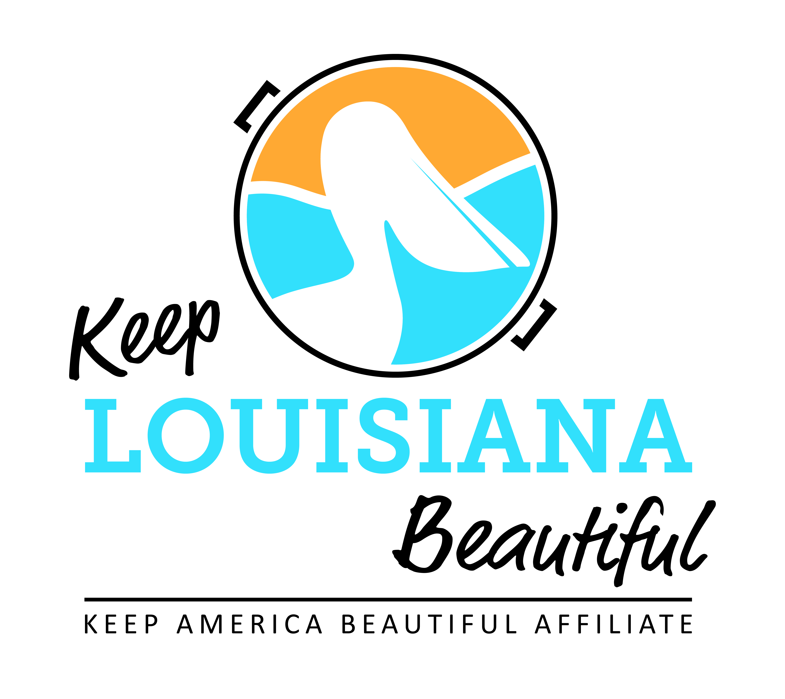

Affiliate Zoom Conference Call Agenda
Thursday 1/21/21
8am or 3pm
Duration: 1 Hour
Link to meeting emailed one week prior.
I. KLB Updates
1) Grants
- Healthy Communities Grant – Letter of Intent accepted January 1- March 5
- Affiliate Grants – Applications accepted January 15 – April 15
  - Cleanup Supplies Grant – *Please note an affiliate that has received this grant for two consecutive years is not eligible to apply this year. The affiliate must take a year off from this grant cycle before applying again.
  - Program Grant
  - Trash Receptacle Grant
  - Environmental Education Grant
  - Applications located on the Affiliate Resource Center

2) Grant Reporting
- Cleanup Supply and Programs Affiliate Grant reports due on or before May 1, 2021
- Reports located on Affiliate Resource Center

3) 2020 Everyday Hero Awards recipients announced
- Virtual State Conference webinars uploaded to KLB website

4) Rocksey’s Environmental Education Workshop – Registration on KLB website
- Date: Saturday, February 20 from 10am to 3pm
- Location: LSU Center for River Studies the Water Campus, 100 Terrance Ave, Baton Rouge

5) Impact Cards – Susan Russell

II. KAB Updates
- Check Affiliate e-newsletter and KAB’s Dashboard for all updates
- GAC trash bags
- KAB contact for Central Region: Grace Keegan gkeegan@kab.org
Phone: 203.659.3032

III. Affiliate Updates

IV. Next affiliate conference call 3/18/21

