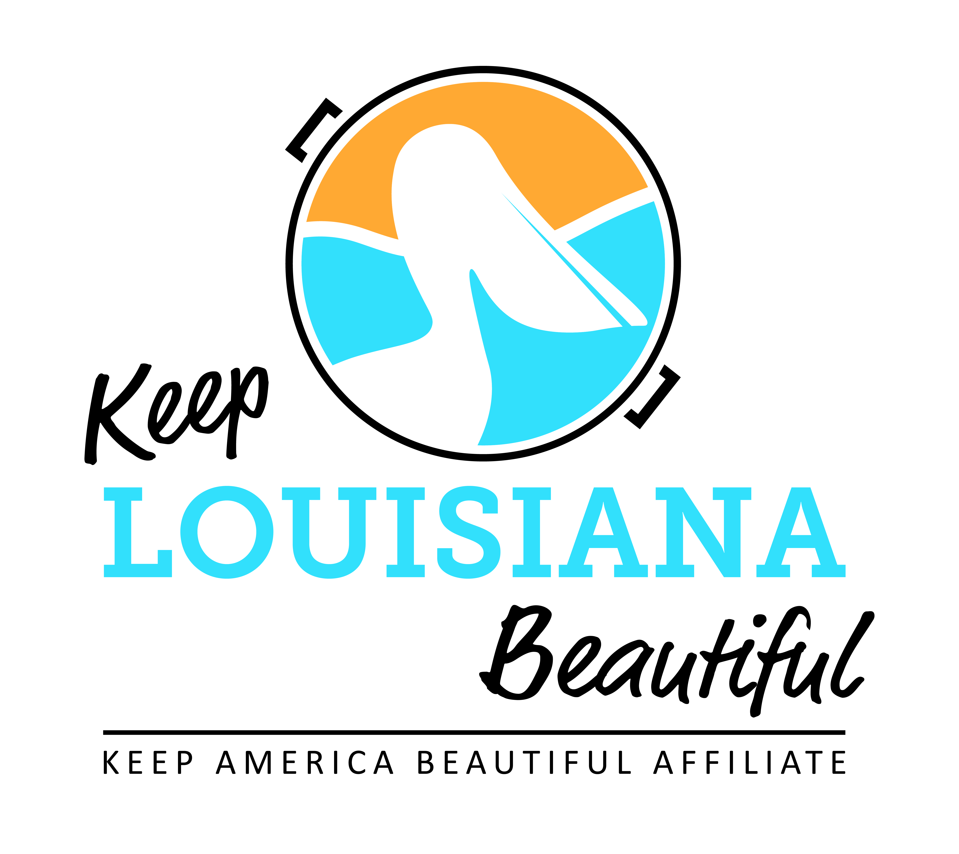

Affiliate Conference Call Agenda
Thursday 9/17/20
8am or 3pm
Duration: 1 Hour

I. KLB Updates
1) KAB Community Restoration and Resiliency Grant
- KLB receives $20,000 grant to assist affiliates in heavily storm damaged areas
- KLB allocating other funds to replace destroyed trash receptacles

2) 2020 State Conference & Everyday Hero Awards
- Conference is going virtual with a free webinar series in November
- Registration required
- Accepting Everyday Hero Award nominations through October 1
- Will honor recipients and Circle of Excellence recipients in January

2) Grant Reporting
- Trash Receptacle Grant litter assessment and report with photos due December 1
- Report located on Affiliate Resource Center

II. KAB Updates
- Check Affiliate e-newsletter and KAB’s Dashboard for all updates
- KAB contact for Central Region: Grace Keegan gkeegan@kab.org
Phone: 203.659.3032

III. Affiliate Updates

IV. Next affiliate conference call 11/19/20

