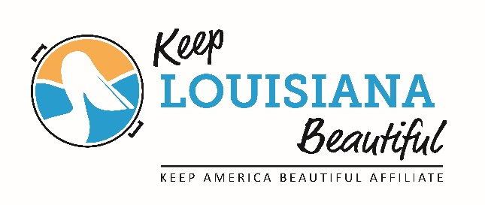
Keep Louisiana Beautiful’s
CIRCLE OF EXCELLENCE AWARD
Requirements
Each year Keep Louisiana Beautiful honors Keep America Beautiful affiliates in Louisiana who meet the benchmarks outlined below. Recipients receive a Circle of Excellence plaque and a $500 cash award* at the annual KLB State Conference in September. The period runs from July 1 to June 30 each year.
Circle of Excellence Requirements:
- August 1: Throughout the year, record outcomes of affiliate projects and efforts. Submit the outcomes data on the Keep Louisiana Beautiful Affiliate Impact Report found on KLB’s website: www.keeplouisianabeautiful.org.
- September: Affiliate Director or board member attend the Annual KLB State Conference.
- April: Affiliate registers and participates in Love the Boot week.
- June: Affiliate Director or board member attend one of the KLB Regional Meetings.
- Ongoing:
- The Affiliate Director or board member participates in at least 3 of the 6 bi-monthly affiliate conference calls conducted by KLB.
- Conduct least one litter removal, waste reduction and beautification event or project each year.
- Be an active Keep America Beautiful affiliate and pay the annual fee.

*Circle of Excellence $500 cash award may be used by the affiliate to cover registration fees and travel expenses for the state conference and regional meetings.

