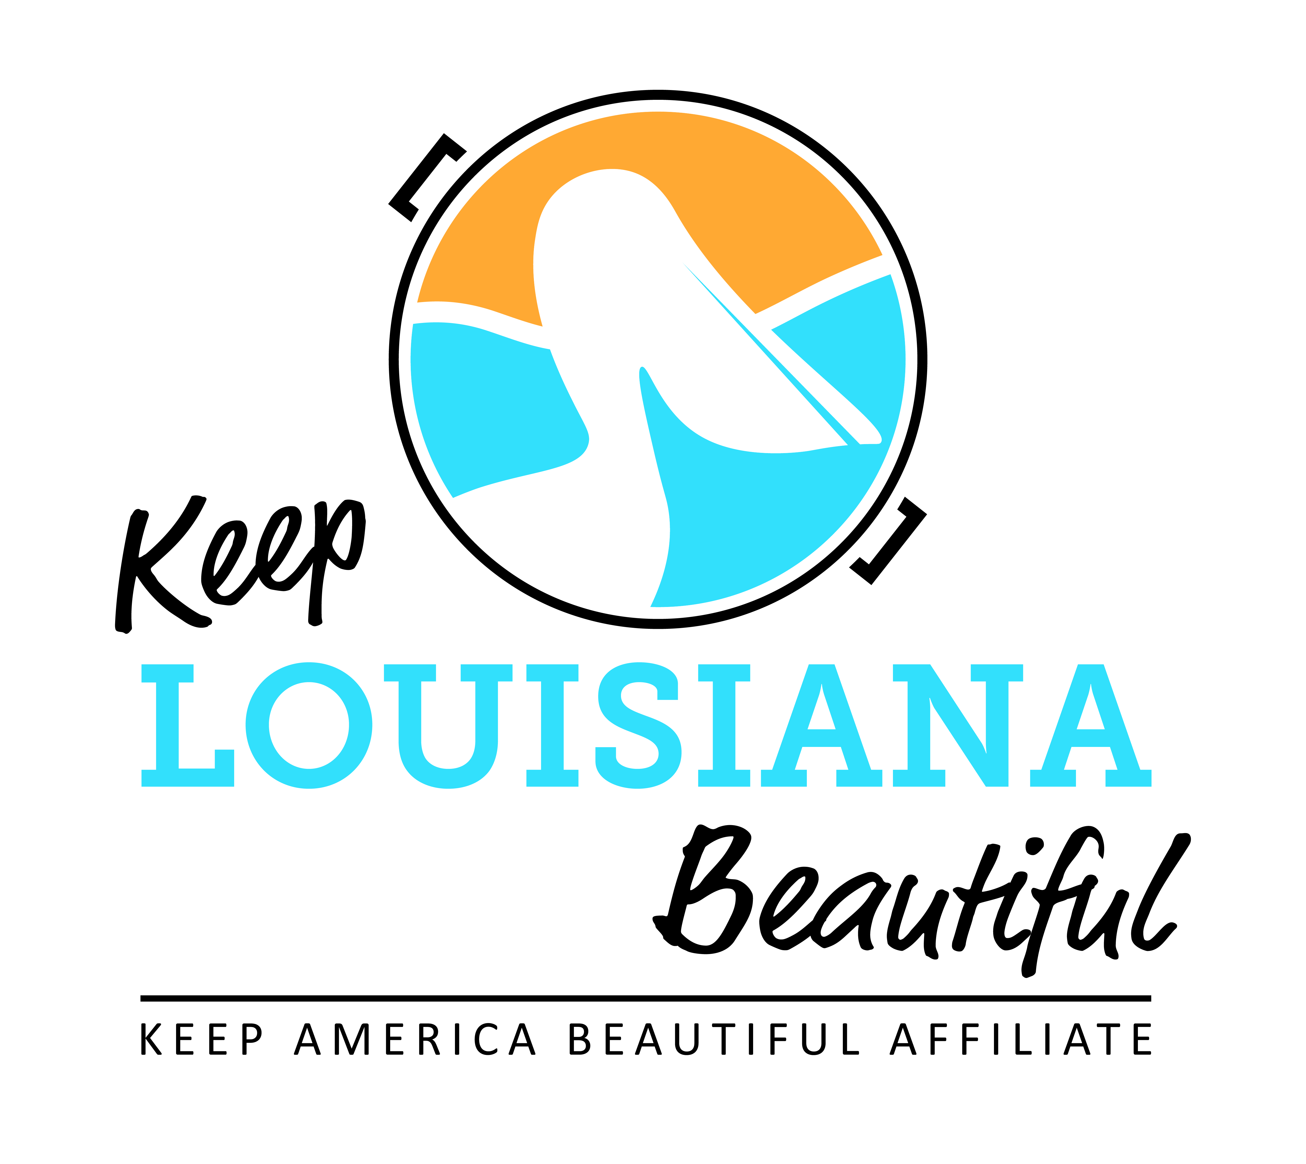

Affiliate Conference Call Agenda
Thursday 5/21/2020
8am or 3pm
Conference Call # (855) 212-0212 & Meeting ID 189-685-802#
Duration: 1 Hour

I. KLB Updates
- 2020 Affiliate Grants Update
- Cleanup Supplies Grant recipients announcement and delivery timeline
- Trash Receptacle Grant recipients announcement and delivery timeline

- Virtual Affiliate Regional Meetings in June
- Regional meetings moving from in person to virtual Zoom meetings
- June 17, 24, and June 25 from 9 – 10:30am
- Registration located on Affiliate Resource Center
- Will email link to Zoom meeting; click on link to join virtual meeting on a device with camera either on laptop, tablet or cellphone
- Topic for each live virtual meeting: The Essential Components of a Strong Grant

- 2020 State Conference Date (NEW DATE)– November 5 -6, Baton Rouge Hilton
- Circle of Excellence award
- Everyday Hero Awards Luncheon – November 6, Heidelberg Ballroom
- Everyday Hero Award Nominations – due October 1 located on ARC

- Litter Enforcement Trainings
- June 17 and June 24 two part webinar series , 1 – 2:30pm
- Registration on ARC
- Rick Moore enforcement@keeplouisianabeautiful.org

- Litter Cleanups Post Pandemic Environment – Susan Russell

- Future Affiliate Bi-Monthly Conference Calls
- Format
- Call dates for new fiscal year:
2020: July 16, September 17, November 19
2021: January 15, March 18, May 20

II. KAB Updates
- Cigarette Litter Prevention Program Grant
- Shreveport Green $20,000
- Keep Tangipahoa Beautiful $2,500
- Regional Director: Grace Keegan, gkeegan@kab.org, 203-659-3032

III. Next affiliate conference call 7/16/20

