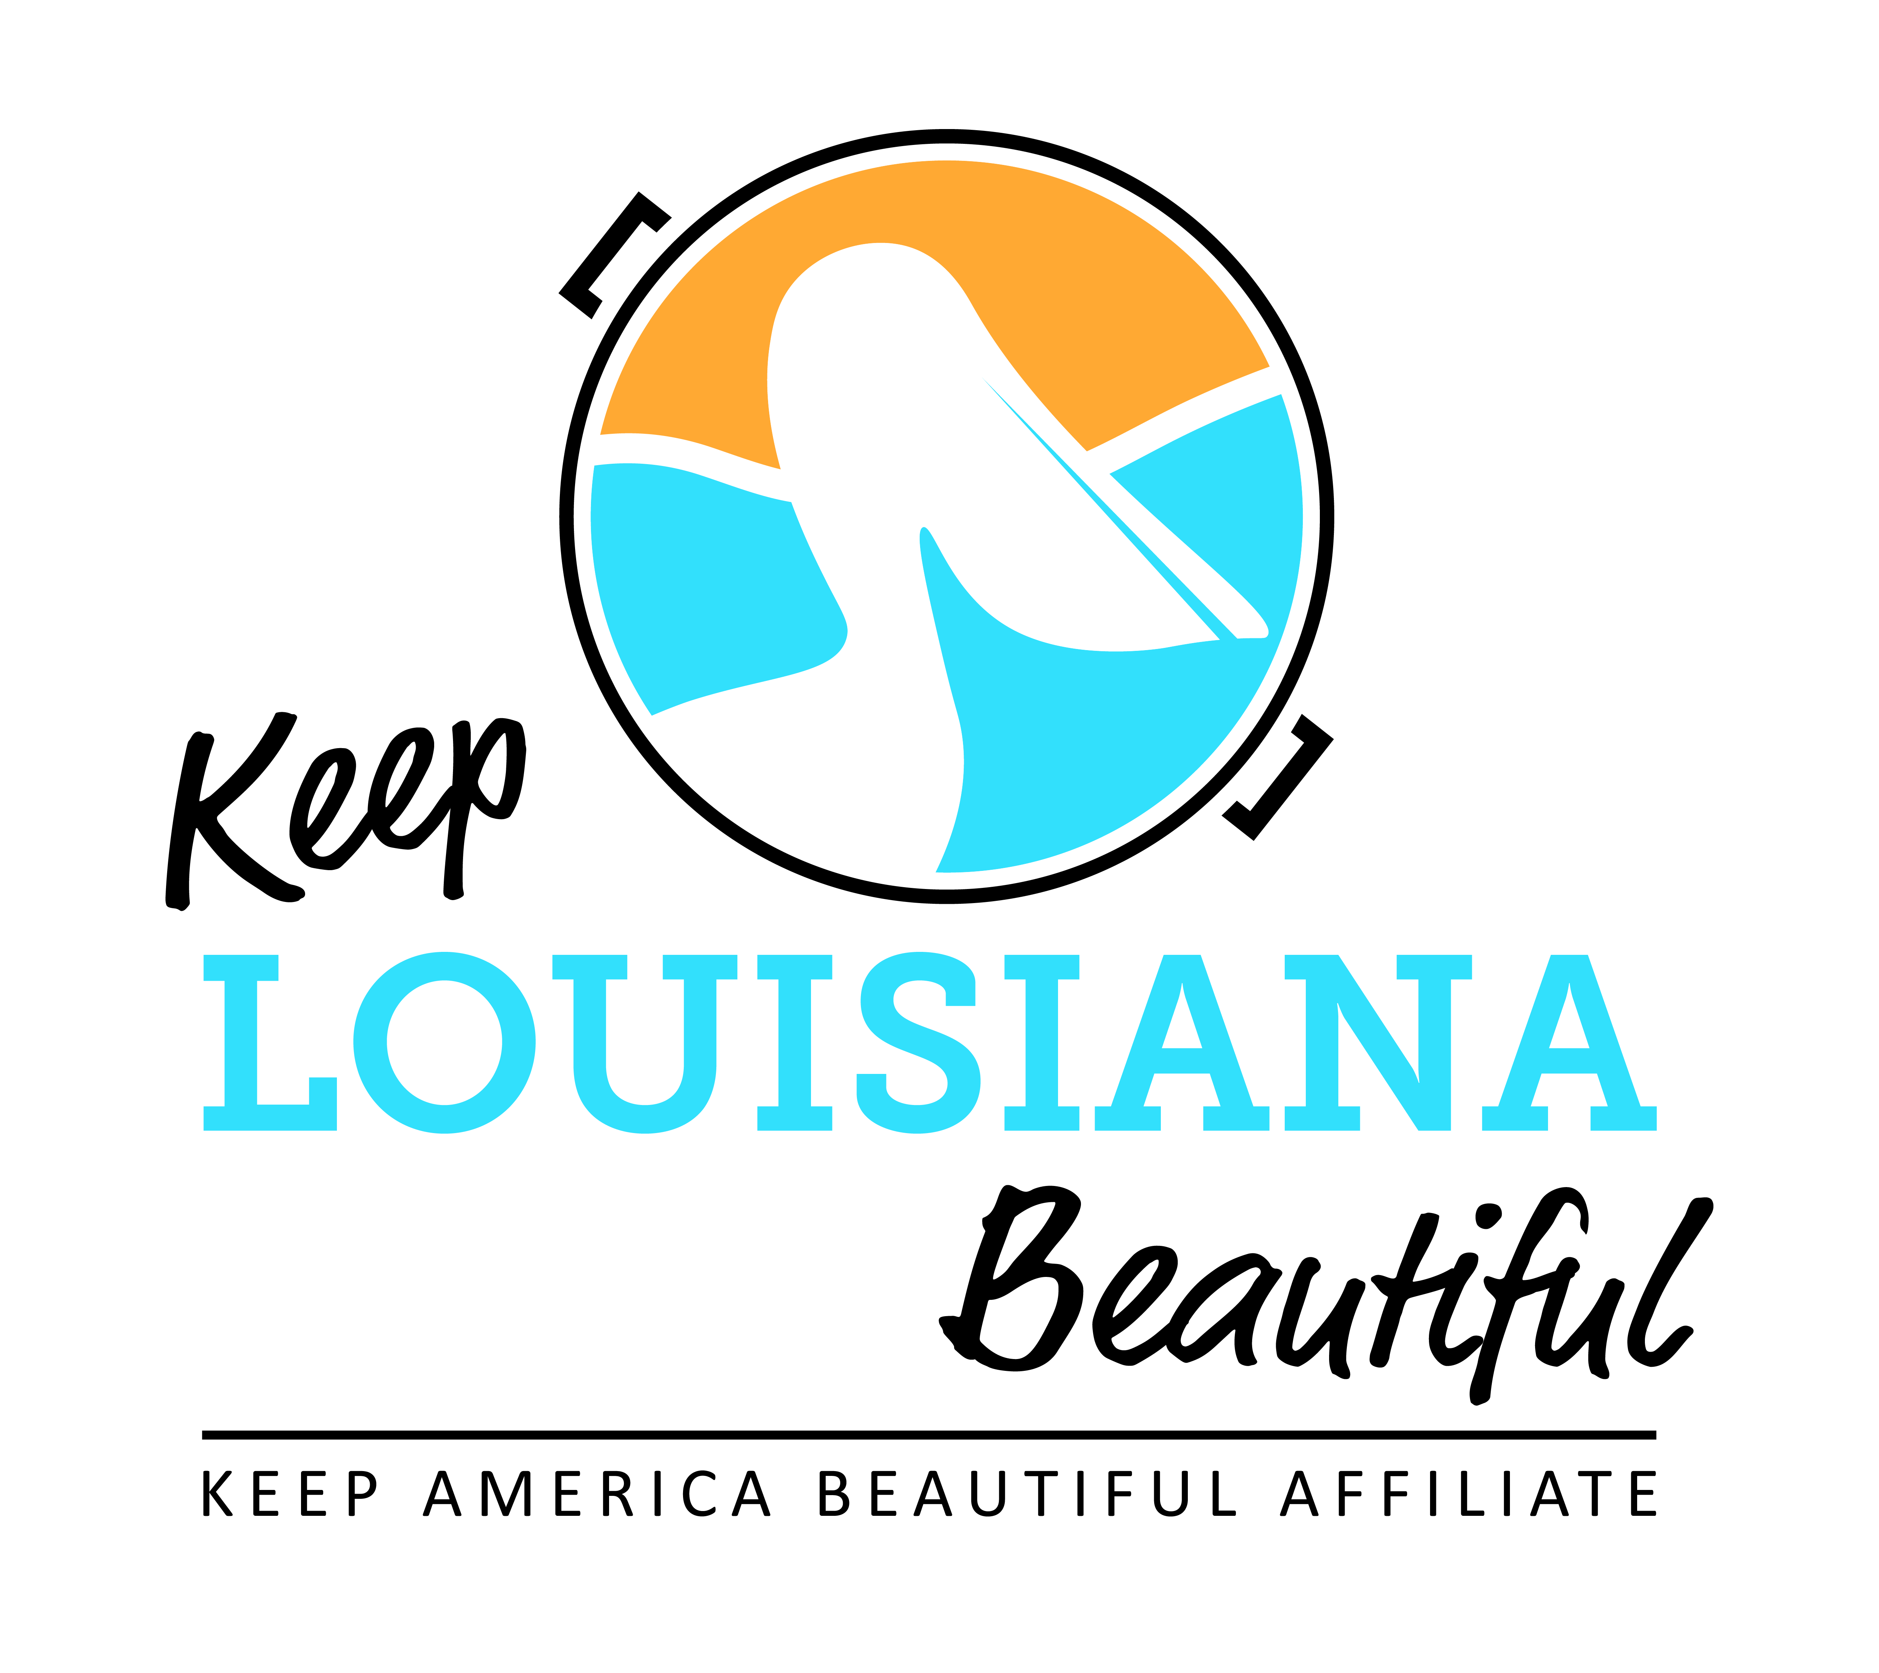

Affiliate Conference Call Agenda
Thursday 3/19/2020
8am or 3pm
Conference Call # (855) 212-0212 & Meeting ID 189-685-802#
Duration: 1 Hour
I. KLB Updates
- KLB Affiliate Grants Update
- 2019-20 Healthy Communities Grant and Affiliate Program Grant - final reports and reimbursement deadline May 1
- 2020-21 KLB Grants – applicants will be notified after July 1

- Regional Meeting Dates and Locations - register by June 1 on Affiliate Resource Center; all meetings 9am – 2:30pm. Agenda can be found on Affiliate Resource Center.
- June 17 – Shreveport/Shreve Memorial Library, Broadmoor Branch, 1212 Captain Shreve Drive 71105
- June 24 – Abbeville/Vermilion Parish Library, 405 E. St. Victor Street, 70510
- June 25 – Baton Rouge/LSU AgCenter Botanical Gardens, 4560 Essen Lane 70809

- 2020 State Conference - September 23-24, 2020; Baton Rouge Hilton

- LTB Week Update (April 20 – 26) – Susan Russell

- LTB Brand Ambassadors/Local LTB media and Lowe’s Gift Cards – Casey Rudolph

- Enforcement Trainings– Rick Moore
- May 19 – Lafayette/Rosa Parks Transportation Center, #116, 101 Jefferson St., Lafayette 70501
- Date TBD – Ruston, Lincoln Parish
- RSVP: enforcement@keeplouisianabeautiful.org

II. KAB Updates
- Trash Bag distribution
- Cigarette Litter Prevention Program Grant – application deadline April 10 for $2,500 - $20,000 grants to focus on cigarette litter reduction through public messaging and infrastructure placement
- Regional Director: Grace Keegan, gkeegan@kab.org, 203-659-3032

III. Affiliate Updates

IV. Next affiliate conference call 5/21/20

