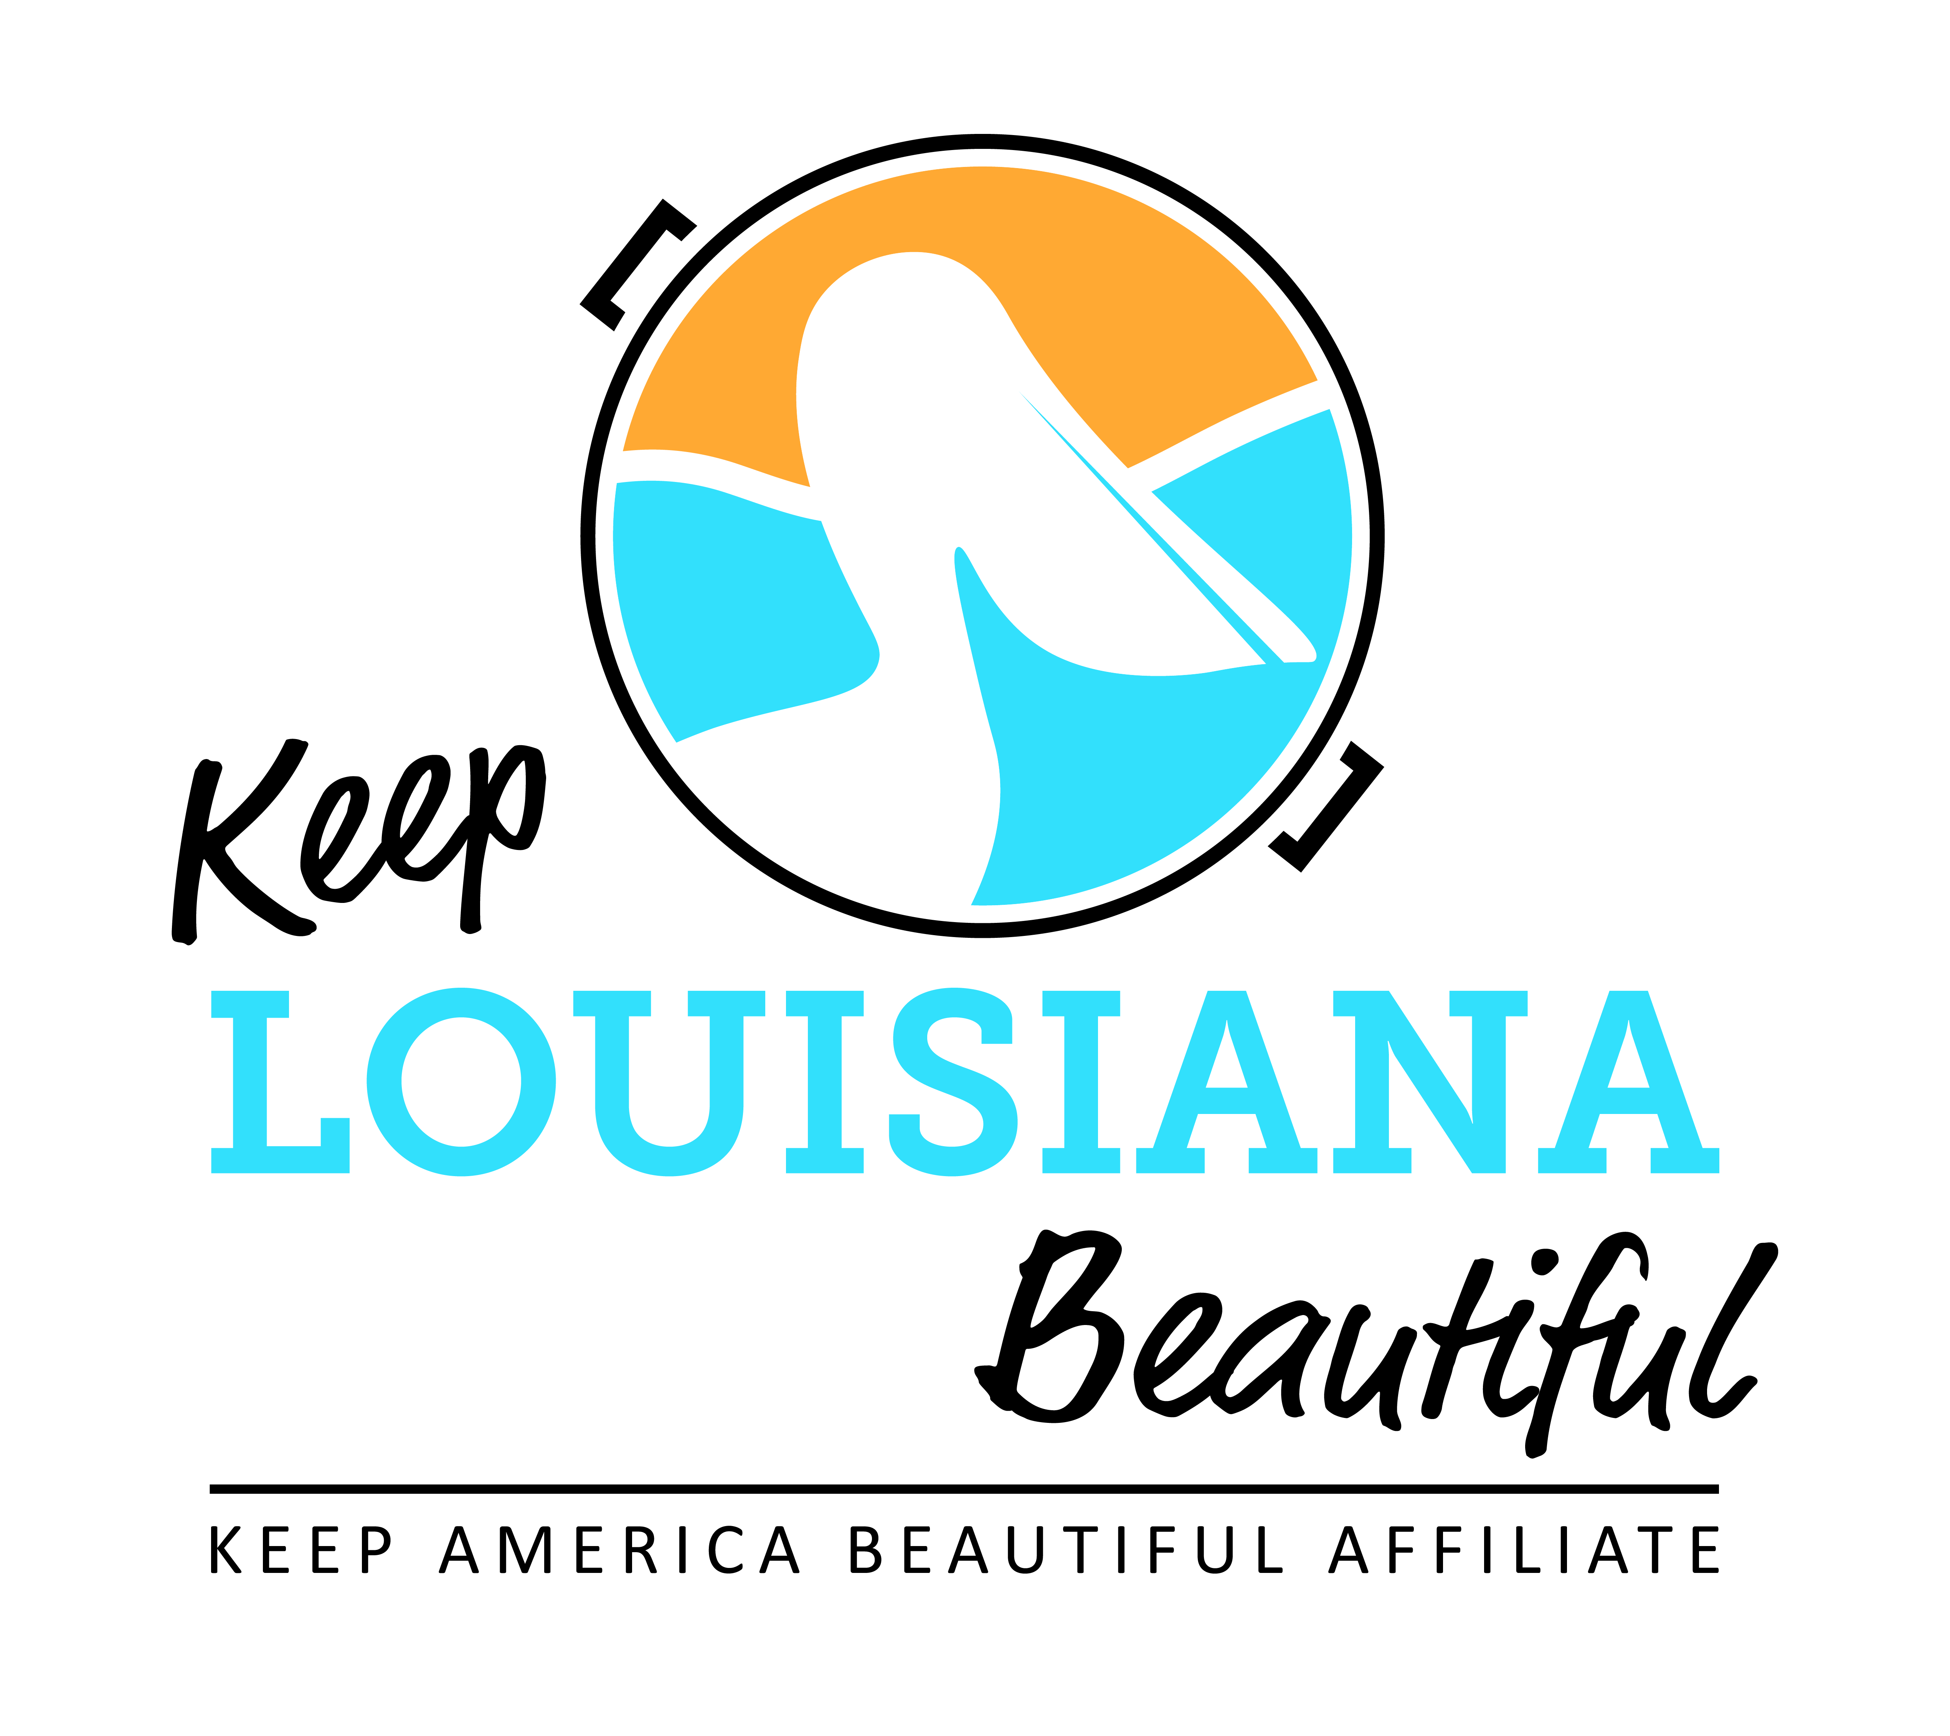

Affiliate Conference Call Agenda
Thursday 1/16/2020
8am or 3pm
Conference Call # (855) 212-0212 & Meeting ID 189-685-802#
Duration: 1 Hour
I. KLB Updates
- 2020 KLB Affiliate Grant Applications – eligible affiliates may apply for up to two different affiliate grants. Online affiliate grant applications found on the Affiliate Resource Center. Healthy Communities Grant Letter of Intent found on KLB website grants page.
2020 KLB Grants open 1/1 | Amount/Items | Letter of Intent | Application Deadline
Affiliate Program Grant | $2,500 | n/a | March 1
Trash Receptacle Affiliate Grant | Up to 5 trash receptacles | n/a | March 1
Cleanup Supplies Affiliate Grant | Grabbers, safety vests, trash bags, gloves, & t-shirts | n/a | March 1
Environmental Education Affiliate Grant | Rocksey Workshop | n/a | March 1 (workshops September – March)
Healthy Communities Letter of Intent | $2,500 up to $8,000 (reimbursement) | March 15 | April 1
2) Rocksey’s Toolbox Workshops
* January 25 – Desoto Parish/523 Oxford Rd, Mansfield
* February 1 – New Orleans/2401 Westbend Parkway, Algiers

3) Regional Affiliate Meetings
* June 17 – Shreveport/Broadmoor Branch Library, 1212 Captain Shreve Drive 71105
* June 23 – Abbeville/Location TBD
* June 25 – Baton Rouge/LSU AgCenter Botanical Gardens at Burden, 4560 Essen Lane 70809

4) LTB Week Update (April 20 – 26), Trash Bags, University Affiliates, Enforcement Trainings– Susan R.

5) Recommendations for education training person for 2020-21, educator for BEP program, and outlets for LTB t-shirt sales – Susan R.

II. KAB Updates
- National Conference in Memphis – February 12-14, 2020 – January 20 deadline for discounted hotel rate
- Affiliate Fees - Invoices sent out first quarter

III. Affiliate Updates

IV. Next affiliate conference call 3/19/20

