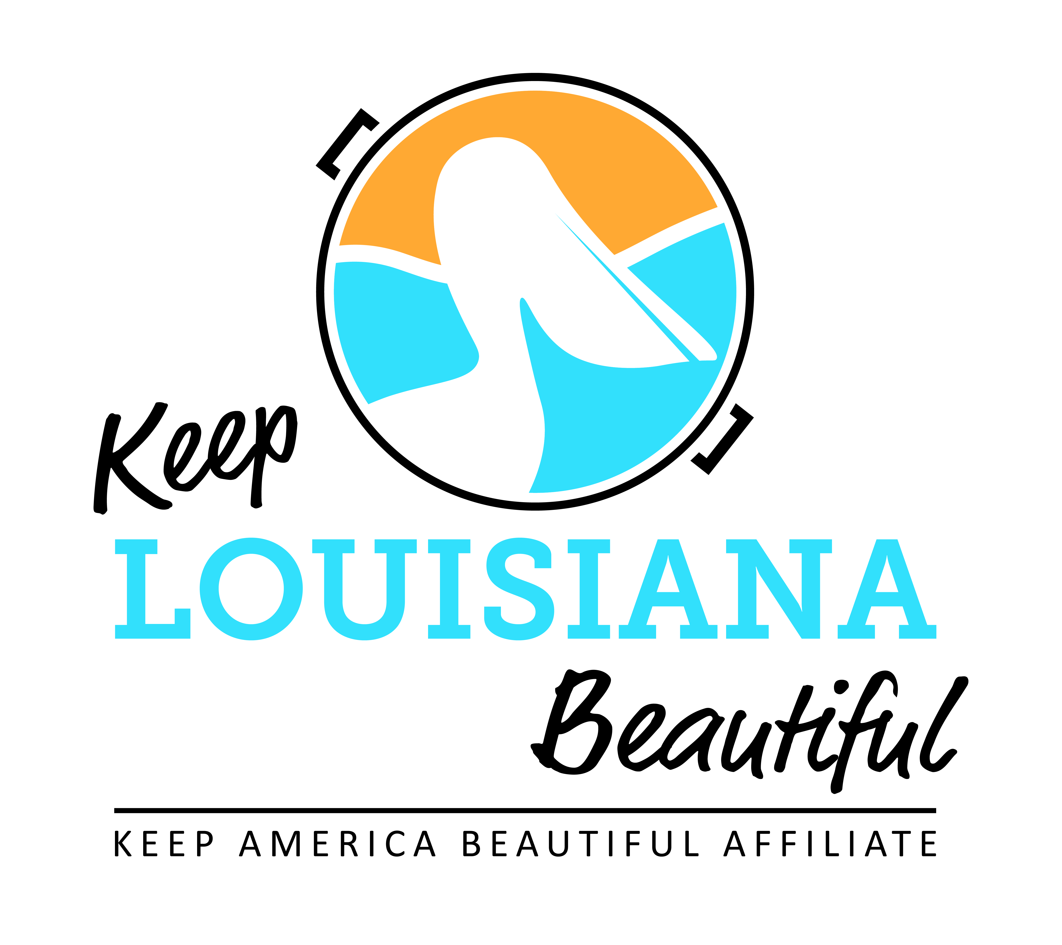
Affiliate Conference Call Agenda
Thursday 11/14/19
8am or 3pm
Conference Call # (855) 212-0212 & Meeting ID 189-685-802#
Duration: 1 Hour
I. KLB Updates
1) 2019-20 Grant Reports Due – all affiliate grant reporting located on KLB website and affiliate resource center
* Affiliate Grants
- Program Grant– due May 1, 2020 or when project/program is completed
- Cleanup Supply – due December 13
- Trash Receptacle – due December 13
- Environmental Education – Due two weeks after date of workshop
* Healthy Communities Grant – Mid-year report due December 3 & final report May 1, 2020

2) 2020-21 Grants – Affiliates meeting Circle of Excellence standards may submit a LOI for a Healthy Communities Grant and/or up to two different affiliate grants.
2020 KLB Grants | Amount | Letter of Intent  2020 | Application Deadline 2020
Healthy Communities | $8,000 | March 15 | April 1
Affiliate Program Grant | $2,500 | n/a | March 1
Trash Receptacle Grant | Up to 5 trash receptacles | n/a | March 1
Cleanup Supplies Affiliate Grant | Grabbers, safety vests, gloves, t-shirts | n/a | March 1
Environmental Education Affiliate Grant | Rocksey Workshops | n/a | March 1 (workshops September – March)
3) 2020 Rocksey’s Toolbox Workshops
* January 25 – Desoto Parish
* February 1 – Shreveport

4) LOVE THE BOOT Week, April 20 – 26, 2020 – Susan Russell

5) Impact Report

II. KAB Updates
* Plogging Kit Grant – Due December 31
* Good Standing
* KAB Contact for Central Region: Grace Keegan gkeegan@kab.org
Phone: 203.659.3032

III. Affiliate Updates

IV. Next affiliate conference call 1/16/20

