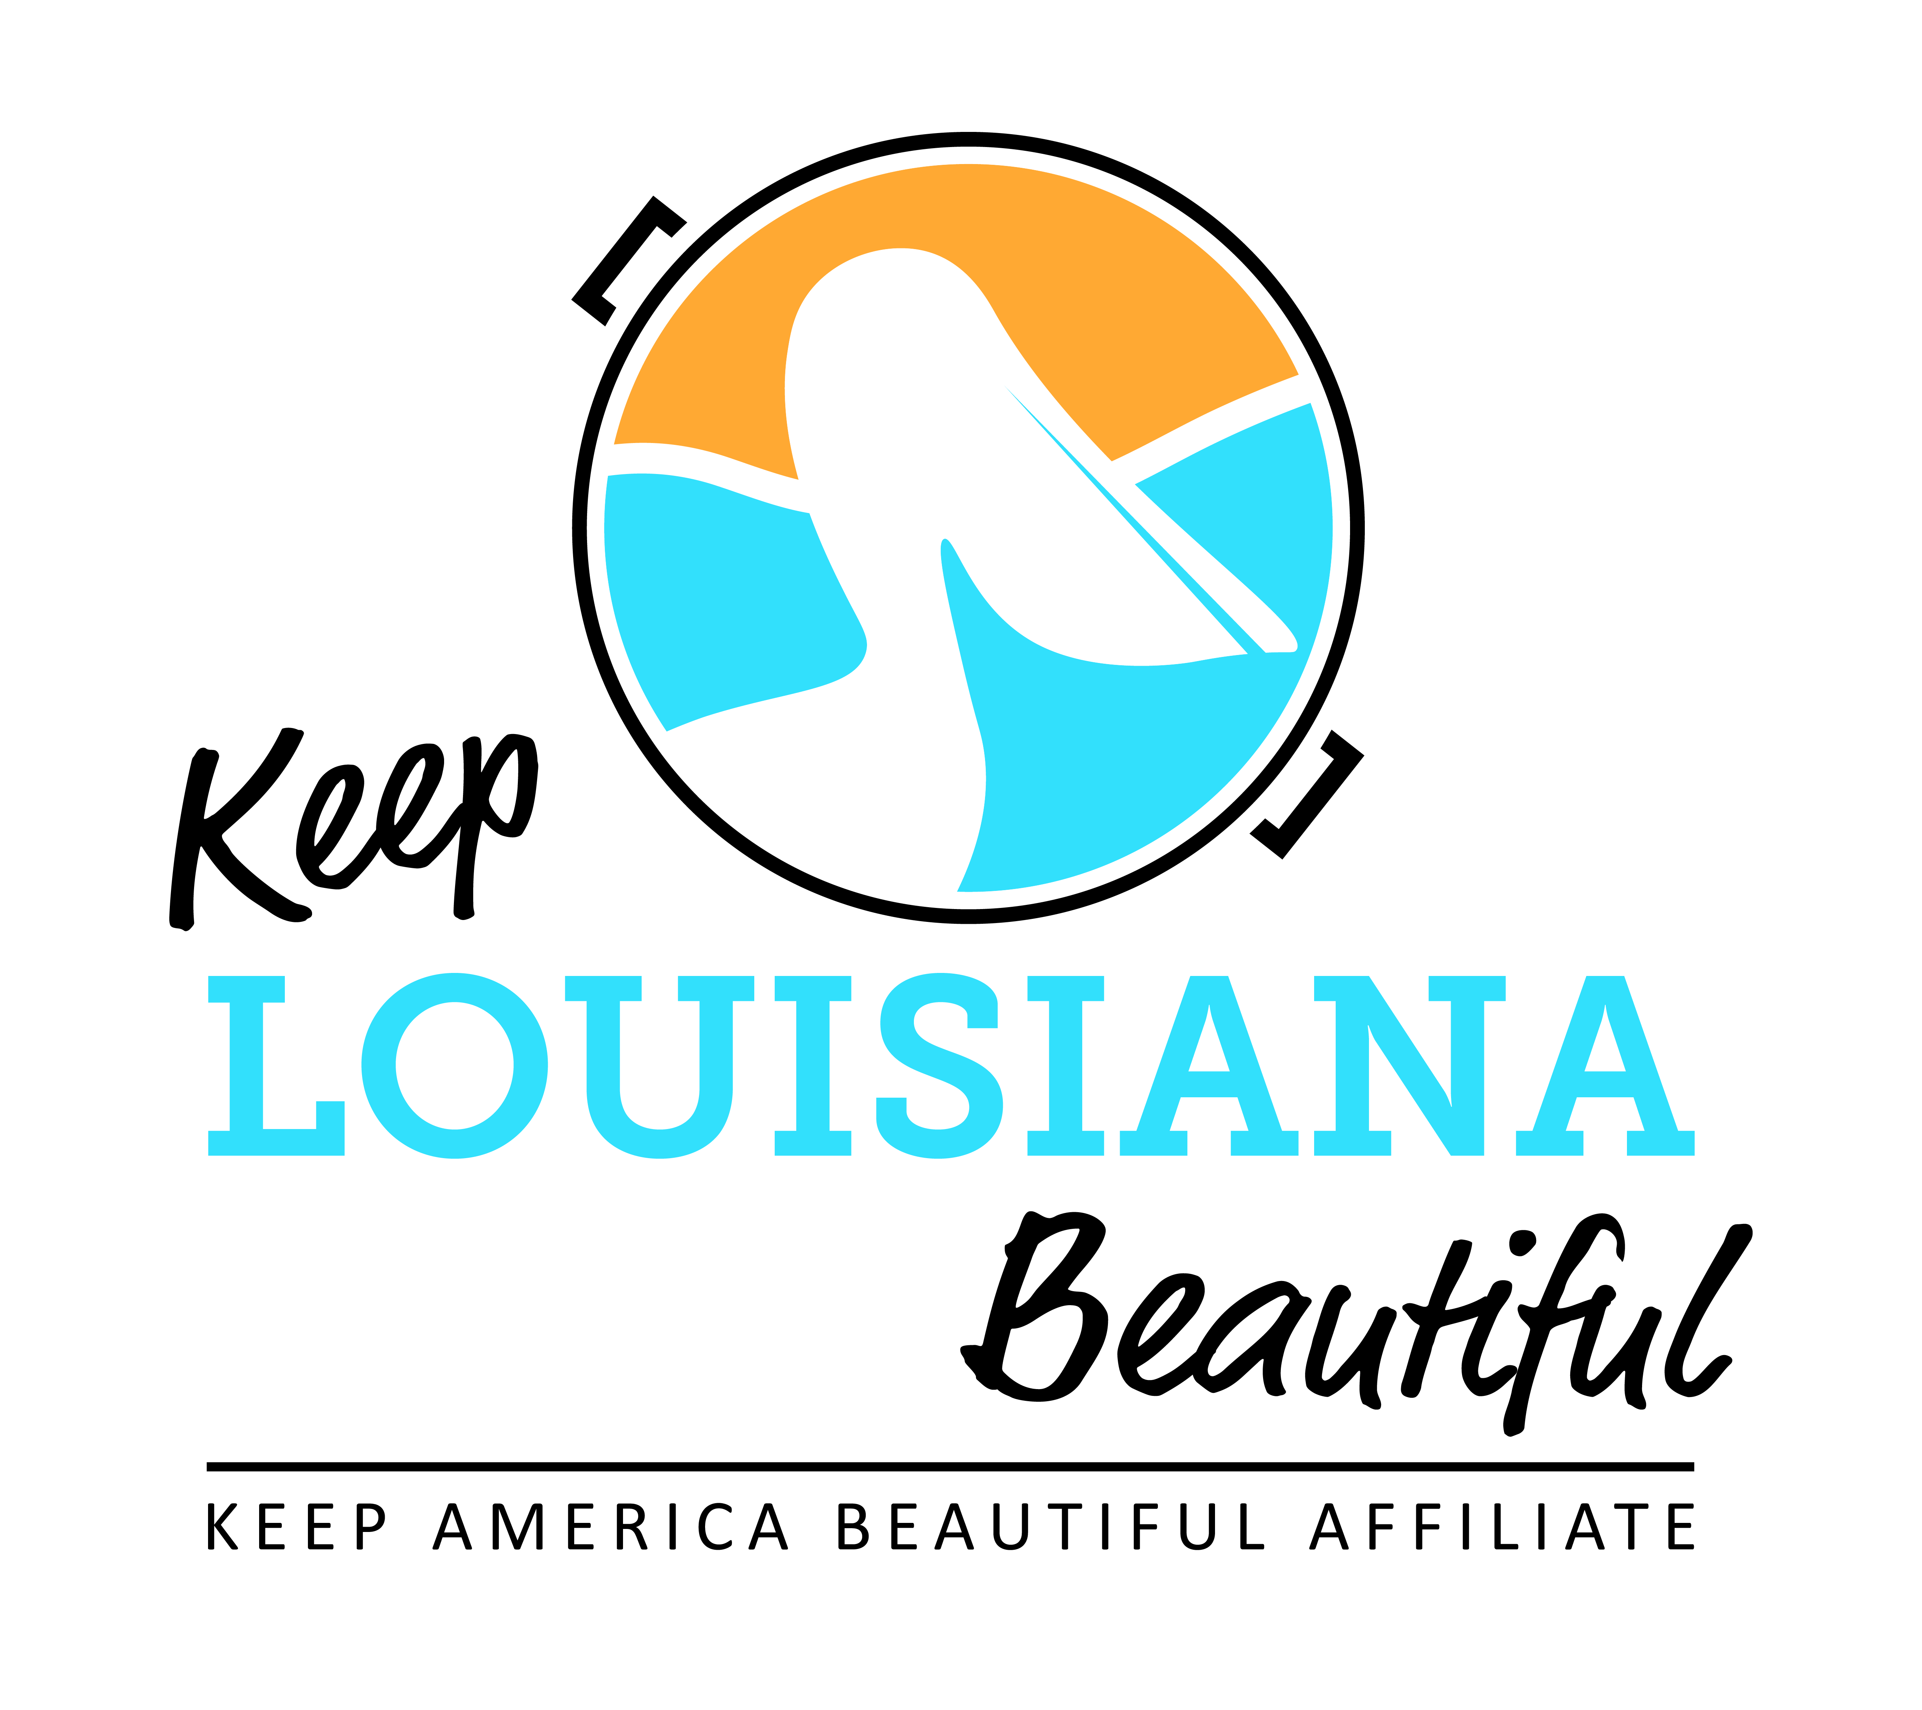
Affiliate Conference Call Agenda
Thursday 9/19/19
8am or 3pm
Conference Call # (855) 212-0212 & Meeting ID 189-685-802#
Duration: 1 Hour

I. KLB

1) State Conference, Hilton Baton Rouge Capitol Center - September 25-26
- Register for conference www.keeplouisianabeautiuful.org/conference/ or on the Affiliate Resource Center
- Affiliate Reception (Casual) for directors and board members, Mezzanine Suite - September 24, 6pm – 8pm RSVP at programs@keeplouisianabeautiful,org or on Affiliate Resource Center
- Awards Banquet, Heidelberg Ballroom - September 25, 6pm
* Cash bar 6-7pm
* Circle of Excellence Award presentation
- Optional LA Recycling Coalition optional recycling track –Thursday, September 26. (Lunch is provided to those that checked box on the registration.)

2) Grants
Affiliate Grant Final Reports on Affiliate Resource Center
* Cleanup Supply Grant report – December 13
* Trash Receptacle Grant report – December 13
* Environmental Affiliate Grant report– due 2 weeks after date of workshop
* Affiliate Program Grant report – May 1, 2020

- Love the Boot Week
* April 20-26, 2020 – Susan Russell

II. KAB
- National Conference in Memphis, TN – February 12-14, 2020
* Consider applying for a national award due October 1. If submitted an EHA you can also submit to KAB. Driving distance if nominee wins.
- KAB Contact for Central Region: Grace Keegan gkeegan@kab.org
Phone: 203.659.3032

III. Affiliate Updates

IV. Next affiliate conference call 11.14.19

