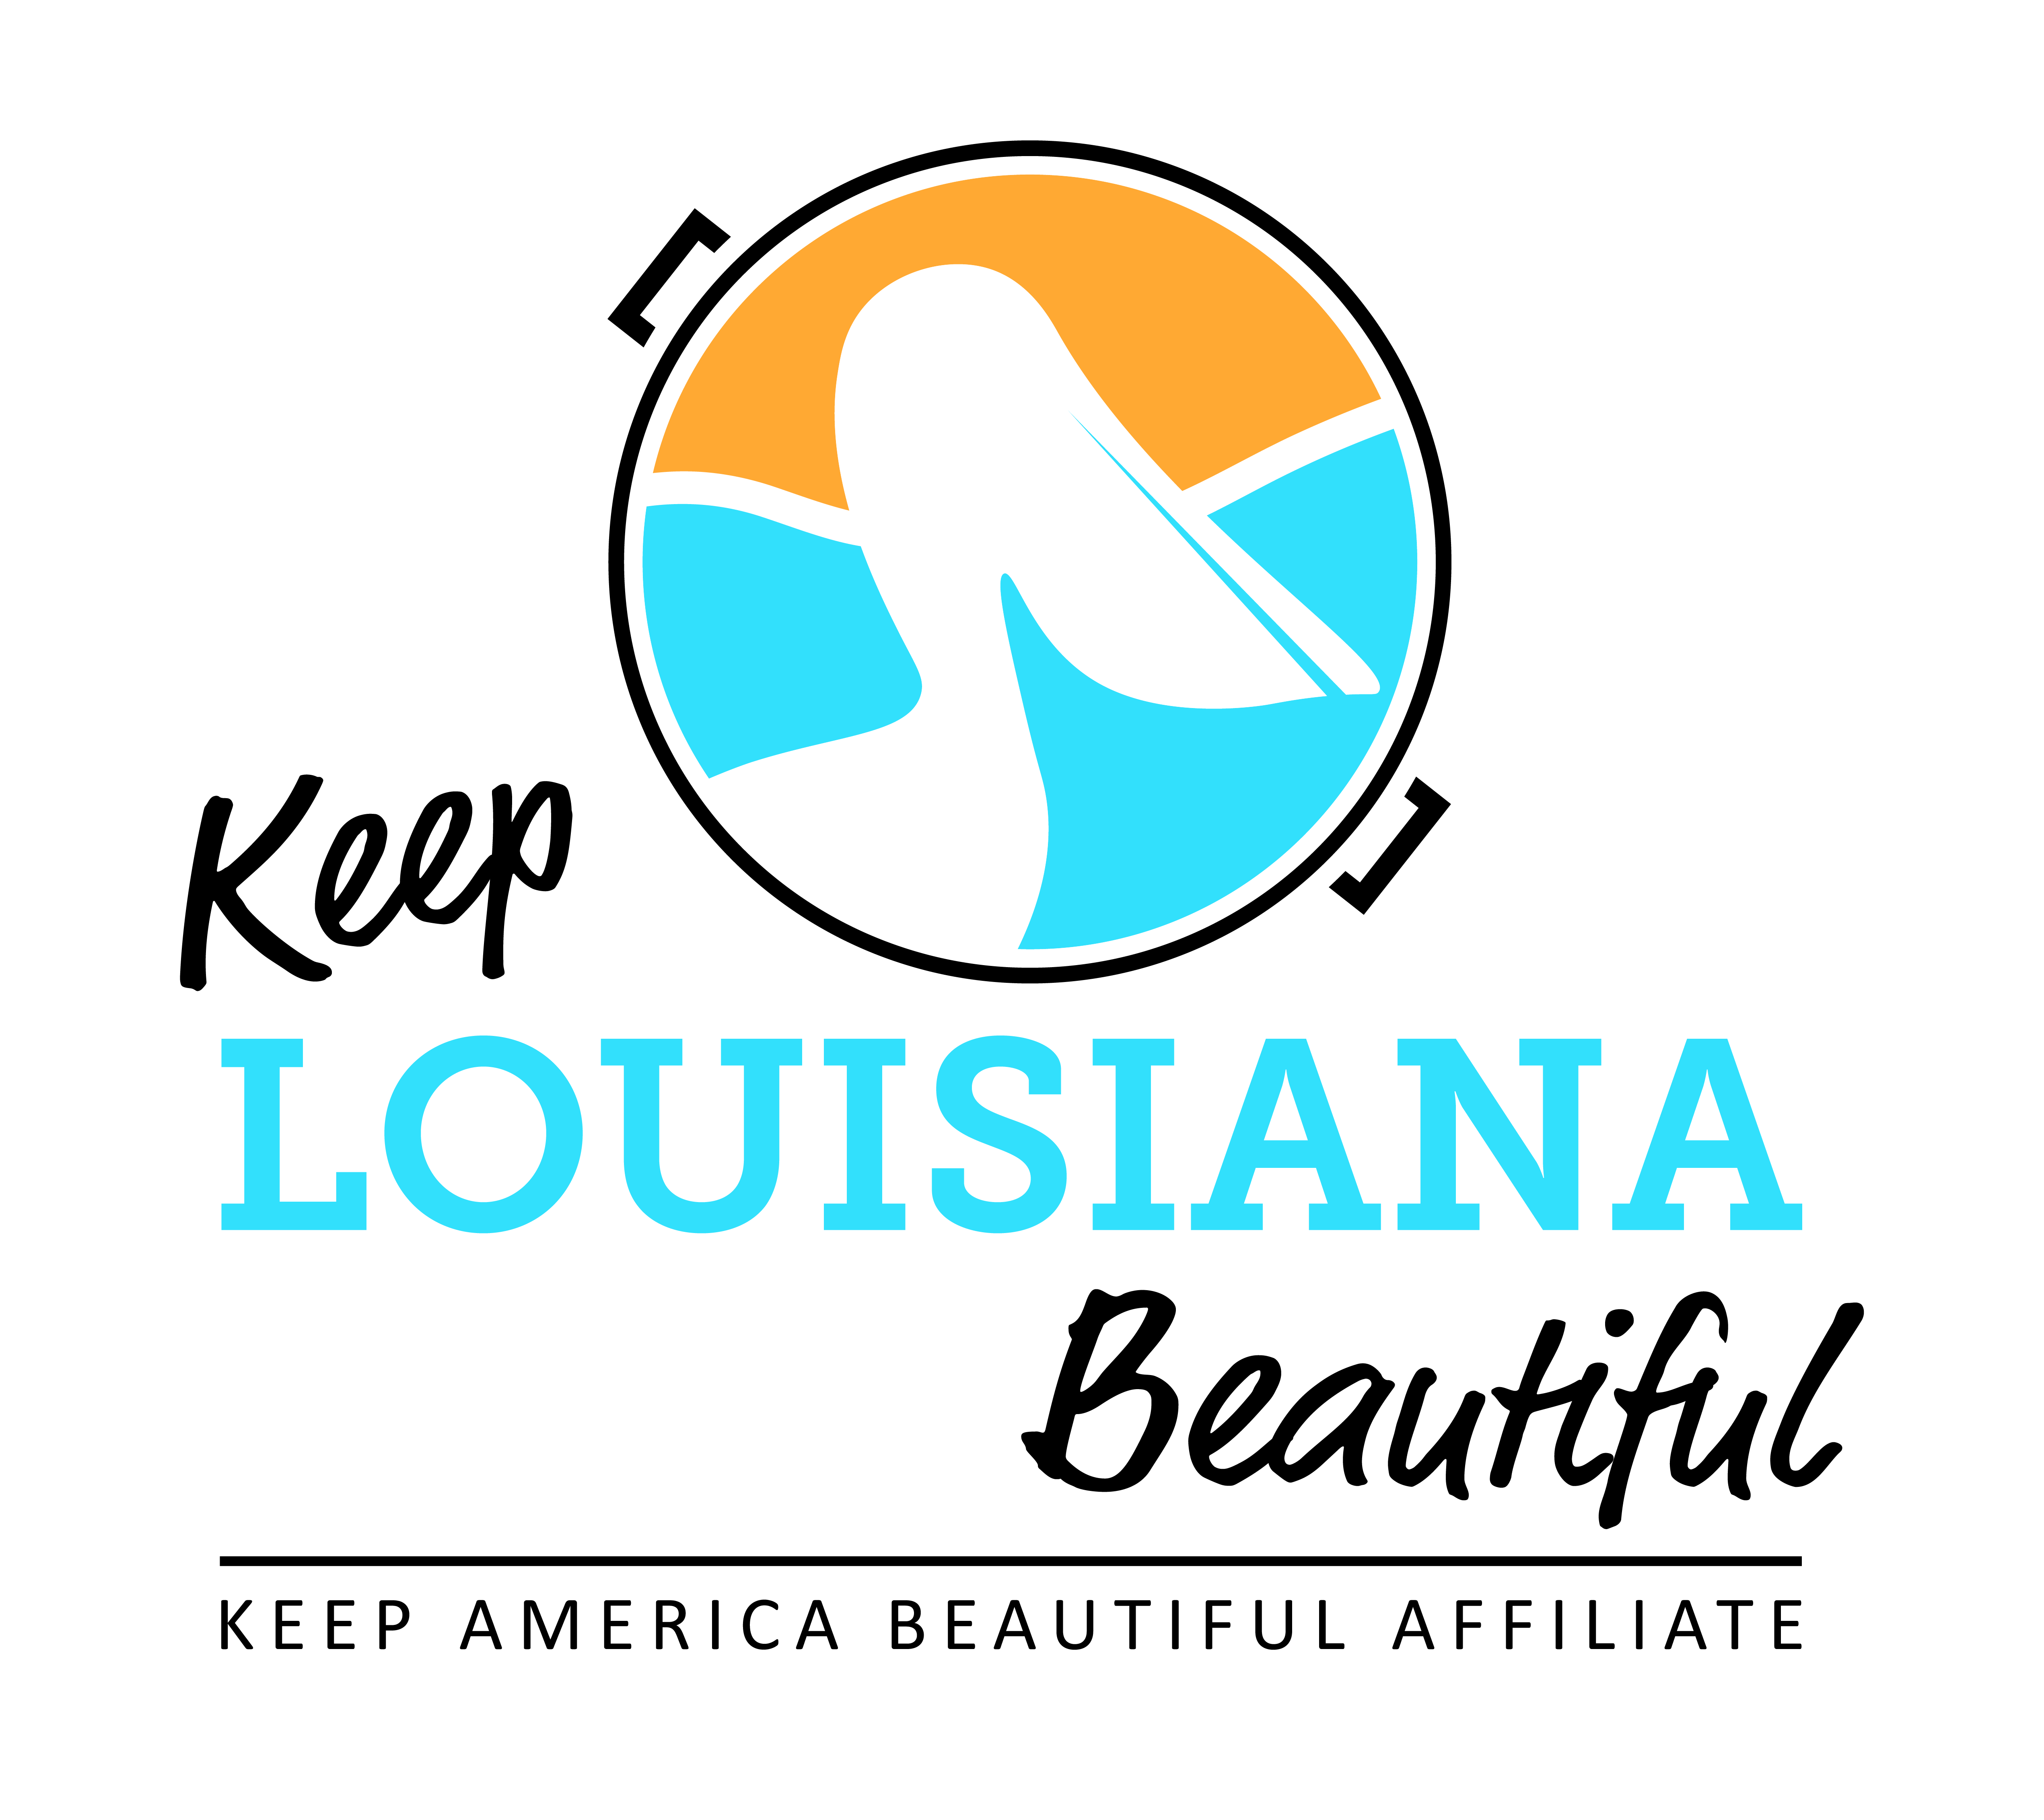

Affiliate Conference Call Agenda
Thursday 3/21/19
8am or 3pm
Conference Call # (855) 212-0212 & Meeting ID 189-685-802#
Duration: 1 Hour
I. KLB Updates
- Regional Meetings Dates and Locations, all meetings 9am -2:30pm
- Register by June 1 through Affiliate Resource Center
- June 7 – Lafayette, Lafayette Parish
Bayou Vermilion Performance Center
300 Fisher Road, Lafayette 70508
- June 18 – West Monroe, Ouachita Parish
Kiroli Park
The Lodge
820 Kiroli Rd, W. Monroe 71291
- June 20 – Folsom, St. Tammany Parish
Little River Bluffs
Legacy & Event Retreat Center
11030 Garden Lane, Folsom 70437
- June 21 – Jefferson, Jefferson Parish
Lafreniere Park
Foundation Center
3000 Downs Boulevard, Metairie 70003
- Cigarette Litter Prevention Program and pocket ashtrays
- Grants Update
- Rocksey’s Toolbox last workshop for 2018-19 school year
- March 16 – Terrebonne
4) Affiliate Impact Report Due August 1
5) State Conference – September 25-26, 2019
* Hilton Capitol Center Baton Rouge
* Hotel reservation code KLB by September 10
* Everyday Hero Award nominations
6) Staff update

II. KAB Updates

III. Affiliate Updates

IV. Next affiliate conference call 5/15/19

