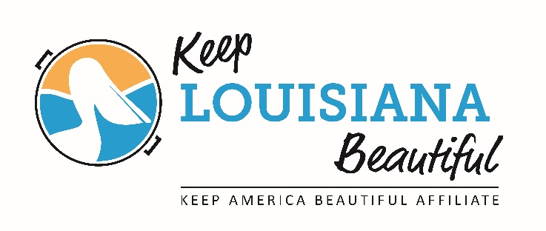
2019 Affiliate Regional Meeting
9am – 2:30pm

- Welcome: Coffee and Informal Networking (9-9:30am)

- The Value of Being an Affiliate (9:30-10:15am) – Susan Russell

- BREAK (10:15-10:30am)

- Show me the MONEY: Overview of KAB/KLB grants (10:30-11:30am) – Cabell Mouton

- Special Recreation Hour (11:30am-12:30pm) – This year we have added a leisure component to the meetings. We will enjoy the beautiful, natural and cultural resources of the area.

JUNE 7: Lafayette, Bayou Vermilion District , Performance Center, 300 Fisher Rd, 70508 – Greg Guidroz, Director of Environmental Awareness, Watershed Museum tour and Rocket Composter demonstration and self-guided tour of Acadiana Village.
JUNE 18: W. Monroe, Kiroli Park, The Lodge, 820 Kiroli Rd, 71291 – Doug Seegers, Director of Parks and Recreation gives walking tour of 500 species of flowers.
JUNE 20: Folsom, Little River Bluffs, Legacy & Event Retreat Center, 11030 Garden Lane, 70437– David Campbell, Author and Founder of Little River Bluffs gives history presentation of the area and walking tour to identify native flowers and flora.
JUNE 21: Metairie, Lafreniere Park, Foundation Center, 3000 Downs Blvd 70003 – Katherine Costanza, Assistant Director of Jefferson Parish Environmental Affairs gives presentation on the “floating islands” in the park lagoon and Barry McGuiness, Park Director speaks on recycling program in the park.

- LUNCH provided by KLB (12:30-1pm)

- Keeping up with the Jones: Important Dates and events by KLB (1-1:30pm) – Susan Russell

- Affiliate “Steal This” (1:30-2:30pm) – Affiliates share successful programs, events, or organization initiatives. (If you bring handouts, have enough for approx. 25 people.)

THINGS TO BRING:
- Reusable water bottle
- Pen and paper
- Affiliate board contact list including emails
- Affiliate by-laws
- Casual/walking shoes
- Sweater in case the room is cold
- A successful idea, program, or organization initiative to share with other affiliates.

THINGS TO KNOW:
- Affiliate directors and board members are invited to register and attend any one of the four meetings.
- The meeting and lunch are free.
- You must register all attendees on KLB’s website (www.keeplouisianabeautiful.org) on the Affiliate Resource Center.
- All meetings will cover the same material but the recreation time will be different depending on the location of the meeting.

