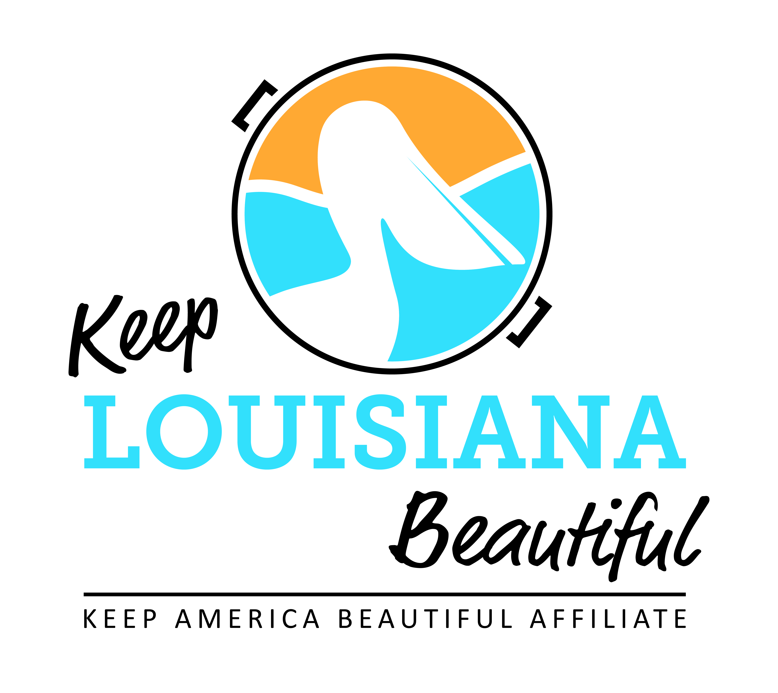

Affiliate Conference Call Agenda
Thursday 1/17/19
8am or 3pm
Conference Call # (855) 212-0212 & Meeting ID 189-685-802#
Duration: 1 Hour
I. KLB Updates
- 2019 KLB affiliate grant applications – affiliates may apply for up to two different affiliate grants. Online affiliate grant applications found on the Affiliate Resource Center. Healthy Communities Grant Letter of Intent found on KLB website grants page.
2019 KLB Grants opens 1/15/19 | Amount/Items | Letter of Intent | Application Deadline
Affiliate Program Grant | $2,500 | n/a | March 1
Trash Receptacle Affiliate Grant | Up to 5 trash receptacles | n/a | March 1
Cleanup Supplies Affiliate Grant | Grabbers, safety vests, trash bags, gloves, & t-shirts | n/a | March 1
Environmental Education Affiliate Grant | Rocksey Workshop | n/a | March 1 (workshops September 2019 – March 2020)
Healthy Communities Letter of Intent | $2,500 up to $8,000 | Due by February 12 | By invitation only March 25

- Leaders Against Litter update and “How to Kit”
- 2018 -2019 Rocksey’s Toolbox workshops scheduled
- January 19 – New Roads
- February 2 – Baton Rouge
- February 9 – Lake Charles
- March 16 - Terrebonne
4) Regional Affiliate Meetings in June – dates and locations TBD
5) Affiliate Impact Report Due August 1
6) State Conference – September 25-26, 2019
* Hilton Capitol Center Baton Rouge
* Topic & presenter ideas for conference discussion
7) Send any spring events info through Affiliate Resource Center

II. KAB Updates
1) National Conference in Baltimore – February 6-8, 2019
2) February 15 – deadline to register for free trash bags for GAC

III. Affiliate Updates

IV. Next affiliate conference call 3/21/19

