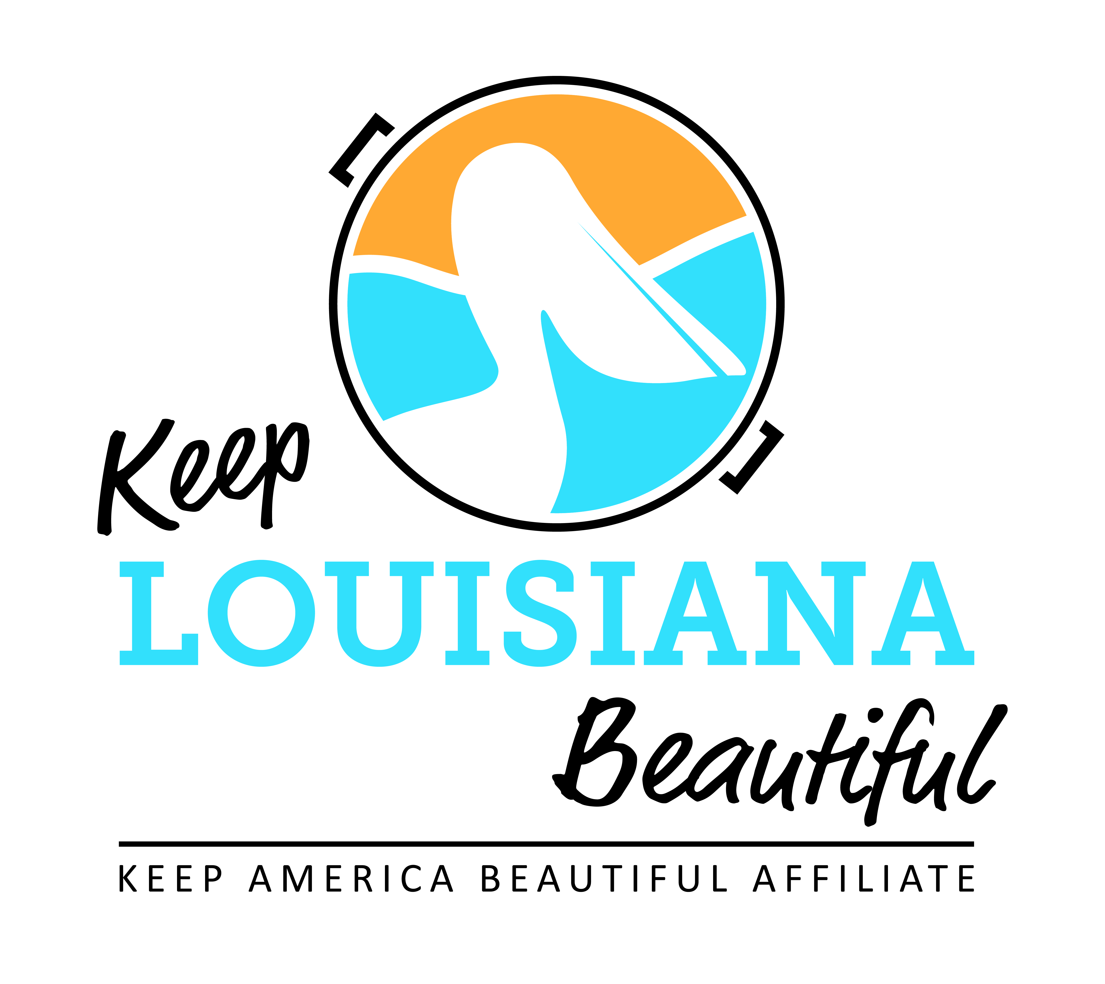
Affiliate Conference Call Agenda
Thursday 9/20/18
8am or 3pm
Conference Call # (855) 212-0212 & Meeting ID 189-685-802#
Duration: 1 Hour

I. KLB Updates
1) State Conference, Hilton Baton Rouge Capitol Center - September 26-27
* Registration due September 21
* Affiliate Reception, Mezzanine Suite - September 25, 6pm
* Affiliate One-on-One with KAB, Grace Keegan
* Optional LA Recycling Coalition optional recycling track – Wednesday, September 26, 3pm
* Everyday Hero Awards Banquet & Circle of Excellence – September 26, 6-9pm

2) Grants
* Trash Receptacle Mini Grant – Report and Assessment due December 3
* Healthy Communities Grant – Mid-year report due December 3
* KLB Grants Moving Forward – Susan Russell

3) Rocksey’s Toolbox Workshops

II. KAB Updates
* Annual Reporting - check with KAB if complete
- Good Standing Reset
* Annual Grants
* KAB Contact for Central Region: Grace Keegan gkeegan@kab.org
Phone: 203.659.3032

III. Affiliate Updates

IV. Next affiliate conference call 11.15.18

