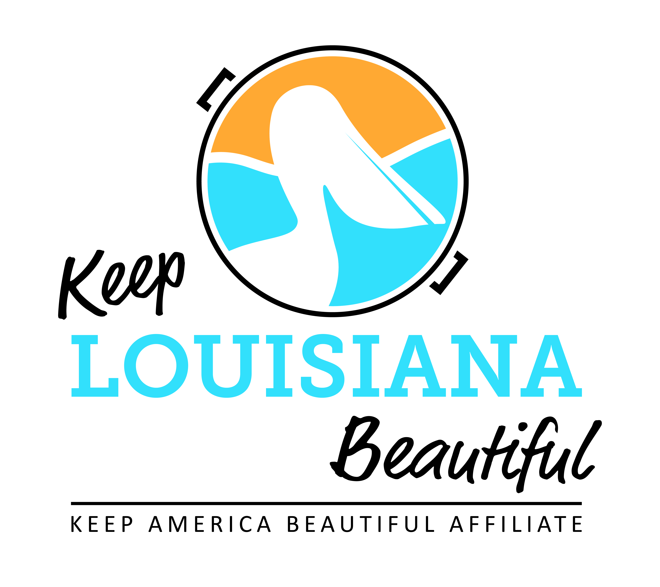
Affiliate Conference Call Agenda
Thursday 7/19/18
8am or 3pm
Conference Call # (855) 212-0212 & Meeting ID 189-685-802#
Duration: 1 Hour

I. KLB Updates
1) Affiliate Impact Report - due August 1
2) State Conference, Hilton Baton Rouge Capitol Center - September 26-27
* Registration Due September 21
* Optional LA Recycling Coalition optional recycling track – Tuesday, September 25
* Affiliate Reception, Mezzanine Suite - September 25, 6pm
* Awards Banquet, Heidelberg Ballroom - September 26, 6pm
* Everyday Hero award nominations due August 31 (submit through the Affiliate Resource Center)
* Circle of Excellence Award – Recipients Announced
3) General Information:
* Grants
-Trash Receptacle Mini Grant - Timeline
-Healthy Communities Grant – Recipients Announced
* KLB/KAB New Fiscal Year July 1, 2018 – June 30, 2019
-Affiliate Bi-monthly calls scheduled
* New KLB office address
902 Coffee Street
Mandeville, LA 70448

II. KAB Updates
* Annual Reporting Due August 1 on Dashboard
- Good Standing Reset
* Central Region Webinar Series – October 3, 2-3pm CDT
* KAB Contact for Central Region: Grace Keegan gkeegan@kab.org
Phone: 203.659.3032

III. Affiliate Updates

IV. Next affiliate conference call 9.20.18

