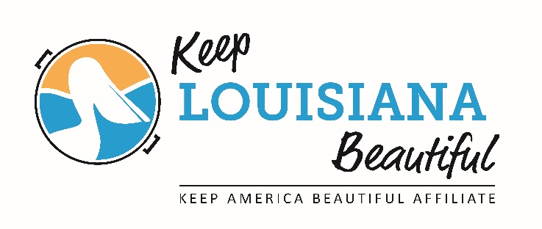
Keep Louisiana Beautiful
2018 Regional Meeting
9am – 3pm

- Welcome (9-9:10am) – Susan Russell

- Introductions and Overview (9:10-9:30am)– Susan Russell

- Data Tracking & How to Use (9:30-10:30am) – Leslie Tate

- Break (10:30-10:40am)

- Community Appearance Index (10:40-11:00am) – Susan Russell

- Affiliate Support Plan & Affiliate Challenges Moving Forward
(11:00-11:45am) - Cabell Mouton & Susan Russell

- LUNCH (11:45am-12:15pm)

- Affiliate Sharing (12:15-3pm)
Each affiliate will have approximately 15-20 min. to share a success story, highlight a program that other affiliates could bring back to their communities. If you have a power point presentation please bring your presentation on a USB stick and handouts for twenty attendees.

*Bring a water bottle, paper and pen to write.

