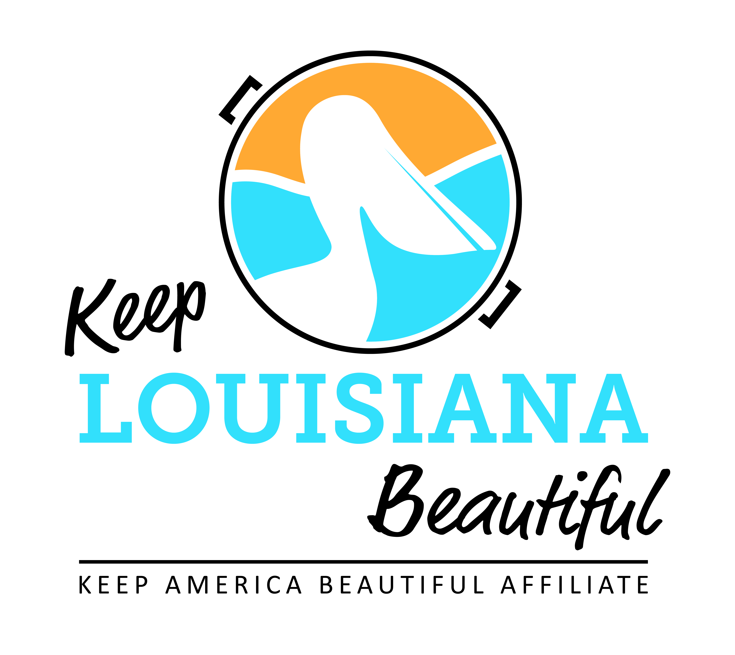
Affiliate Conference Call Agenda
Thursday 3/15/18
8am or 3pm
Conference Call # (855) 212-0212 & Meeting ID 189-685-802#
Duration: 1 Hour

I. Affiliate Updates

II. KLB Updates
- Leaders Against Litter 3/23/18
* Day of Report
* Press Conference 2pm, Capital Park Welcome Center, 702 River Rd, Baton Rouge
* Reception following press conference at Lt. Billy Nungesser’s Apartment
- 2018 KLB Grant Applications are Open
* Trash Receptacle Mini Grant – Deadline 4/6/18
* Healthy Communities Grant – Deadline 4/6/18
3) Legislative Day – 4/23/18
* State Capitol Rotunda, 10am-3pm
4) 2018 Regional Meetings
* 7/12 – Lincoln Parish
* 7/13 – St. Martin Parish
* 7/19 – Covington
* 7/21 – St. James Parish
5) State Conference 9/26/18 – 9/27/18
* Location Details
6) New Orleans Saints Update
7) Send any events information through Affiliate Resource Center

III. KAB Updates
*Great American Cleanup Launches 3/20/18
* KAB Contact: Grace Keegan gkeegan@kab.org Phone :203.659.3032

IV. Next affiliate conference call 5/17/18

