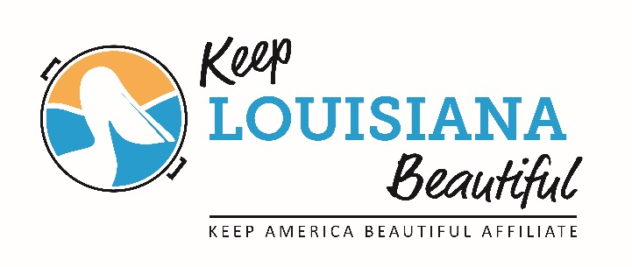
2016 Annual State Conference Registration Form
Galvez Building Conference Center 602 North 5th St. Baton Rouge September 28 & 29

Name ___________________________________________________________________________________

Company Affiliation_________________________________________________________________________

Address __________________________________________________________________________________

City, State, Zip _____________________________________________________________________________

Email ____________________________________________ Phone__________________________________

General Registration Fee:
Registration includes all conference sessions on Wednesday and Thursday, lunch on both days and one ticket to the Award’s Banquet on Wednesday night.

One Regular Registration Fee until Sept. 12th $100 __________
One Registration after Sept. 12th $125 __________

Single Day Registration Fee: Includes lunch.
Single Day conference only ⃝ Wednesday ⃝ Thursday $50 __________

Additional KLB Award’s Banquet Tickets: $50 x ( ) = __________
The award’s banquet will be on Wednesday night. Cocktails begin at 6:30 pm and banquet at 7pm.
Dress attire - business dressy or semi-formal.

*I request a vegetarian dinner: Quantity (_______)

Exhibitor Fee: $250 __________
Includes one 6ft. table and registration for one person to attend conference sessions on
Wednesday and Thursday day. Contact skelley@keeplousisanabeautiful.org details.

TOTAL ENCLOSED $ __________

Make check payable to Keep Louisiana Beautiful. Mail with registration form to: P. O. Box 8990, Mandeville, LA 70470

Credit Card Payment. □ Visa □ American □ Master Card □ Discovery
Name as it appears on card:________________________________________________________________________

Card #:___________________________________________________3 digit code on back _______________

Expiration Date:_____/______________ Amount:______________ Zip code____________

Email form to: Srussell@keeplouisianabeautiful.org

HOTEL ACCOMMODATIONS:
The beautiful Hilton Baton Rouge Capitol Center will be the host hotel for the conference. Located at 201 Lafayette Street, Baton Rouge, rooms may be reserved for $94/night by calling 1-800-955-6962. Mention that you are with the Keep Louisiana Beautiful group when booking and make your reservations prior to Sept. 6th. Event parking is available for $10 per day. Lots are located at Florida and Lafayette or Convention and Lafayette streets. Limited shuttle service provided from hotel to Galvez Building Conference Center.

CONFERENCE LOCATION AND PARKING:
The conference will be held in the Oliver Pollock and Pensacola Rooms in the LDEQ Galvez Building Conference Center located at 602 North 5th Street. Conference parking for the Galvez Conference Center is located at Galvez Parking Garage located at 504 Main Street. Parking will be free for registered conference attendees with a validated ticket.

Questions? Please email Sarah Kelley at skelley@keeplouisianabeautiful.org or call 985-502-9024.

KLB State Conference Schedule

Tuesday, September 27
6pm -9 pm KLB Board and Affiliate Reception – A casual reception will be held for board members and affiliates at the Hilton Baton Rouge Capitol Center Mezzanine Suite. This is a great time to network with your peers. We will distribute Leaders Against Litter supplies to participating affiliates at this time. (board and affiliates only)

Wednesday, September 28 DEQ Galvez Building Conference Center 602 North St.
9 am Affiliate Meeting: KAB NEW Reporting (affiliates only)

10am Conference Openings: Kip Holden, Mayor of Baton Rouge and Denise Bennett, LDEQ Deputy Secretary

Session 1: Keynote – How to bring about behavioral change by Dr. Wes Schultz Dr. Schultz is a professor of psychology at California State University. He has over 20 years of experience working on the behavioral dimensions of sustainability issues. He is the author of seven books and published 100 articles in leading scientific journals and edited volumes. His work has been featured in numerous media outlets including Wall Street Journal, New York Times, National Public Radio and the BBC.

Lunch

Session 2: Reusing, Reducing and Recycling:
Refocusing on Reduce, Reuse and Recycle by Brenda Pulley, Keep America Beautiful

Recycling Panel-
- Refill Not Landfill: Using refillable bottles makes sense, by Tammy Millican, LSU
- How to make your case for school recycling by Gretchen Vanicor, ULL
- Recycling at festivals by Greg Guidry, Bayou Vermilion District
- Eco Green Events: Integrating Sustainability into community events and planning by Valerie Longa, Alabama Coastal Foundation.

Session 3: Fundraising:
How to raise money to fund your work by Mike Rogers, Keep America Beautiful
History and Highlights of KLB’s grants program by Sarah Kelley, KLB Affiliate Coordinator

4:30 Closing

Wednesday Night Awards Banquet located in the Hilton Baton Rouge Capitol Center Heidelberg Ballroom on the 10th Floor

6:30 - 7:00 Cocktails

7:00 - 9:00 Awards Banquet -- Invited guests: Governor John Bel Edwards. Presentation of the Everyday Heroes awards and Circle of Excellence Awards.

Thursday, September 29 DEQ Galvez Building Conference Center 602 N. 5th Street
8 am Affiliate Meeting: KLB updates. How to be a behavioral change organization (affiliates only)

9 am Conference Opening

Session 4 Blight:
Part 1: Cutting Down on Vacancy and Blight: Planning and Tools for Communities by Alexandra
Miller, Asakura Robinson
Part 2: How to calculate the cost blight has on your community. Literature review by Cecile Caron, Keep America Beautiful

Session 5 Environmental Enforcement:
How to establish a litter court in your community by Rick Moore, St. Tammany Parish Constable

Session 6 Louisiana’s new anti-litter slogan by First Lady Donna Edwards and DEQ Sec. Dr. Brown

Lunch
Session 7 Common sense solutions to waste, litter and pollution at the city level, by Max Ciolino, No Waste NOLA.
Session 8 KLB Grants Overview by Sarah Kelley, KLB Affiliate and Program Coordinator

Session 9 Roadside Litter: Reducing roadside litter by targeting motorists by Susan Russell, KLB Ex. Director

Session 10 Education: KLB rolls out its new Environmental Education Program, by Susan Russell, KLB Ex. Director

2pm Conference Closing

2:30 pm – 3:30 pm New Affiliate Director Training (new affiliate director’s only)

